Polygonal-Region Generator

Definition
# Source: AI Source: Provided by: [Data Path: Persons Table -> ID Column: 1, Name_En Column: Motasem Essam] -> From: [ChatGPT] on [7/25/2026]
A Polygonal-Region Generator is a plane-region generator that uses a filled polygonal region as its generating figure to produce three-dimensional solids through translation, rotation, extrusion, or other spatial movements.
A polygonal region is a two-dimensional area enclosed by a closed polygon consisting of three or more straight sides.
The most important applications include:
- Translating a polygonal region to generate a Prism.
- Translating it with a continuously changing scale toward a point to generate a Pyramid.
- Rotating it around an axis in its plane to generate a Solid of Revolution.
- Sweeping it along a general path to generate a Polygonal Swept Solid.
The resulting solid depends on the polygon's shape, its dimensions, and the movement applied to it.
Important distinction:
- A polygonal region is the filled area enclosed by the polygon.
- A polygonal boundary consists only of its sides and vertices.
- Sweeping a filled polygonal region through space generates a solid, while sweeping only its boundary generally generates surfaces.

Geometric Representation
# Source: AI Source: Provided by: [Data Path: Persons Table -> ID Column: 1, Name_En Column: Motasem Essam] -> From: [ChatGPT] on [7/25/2026]
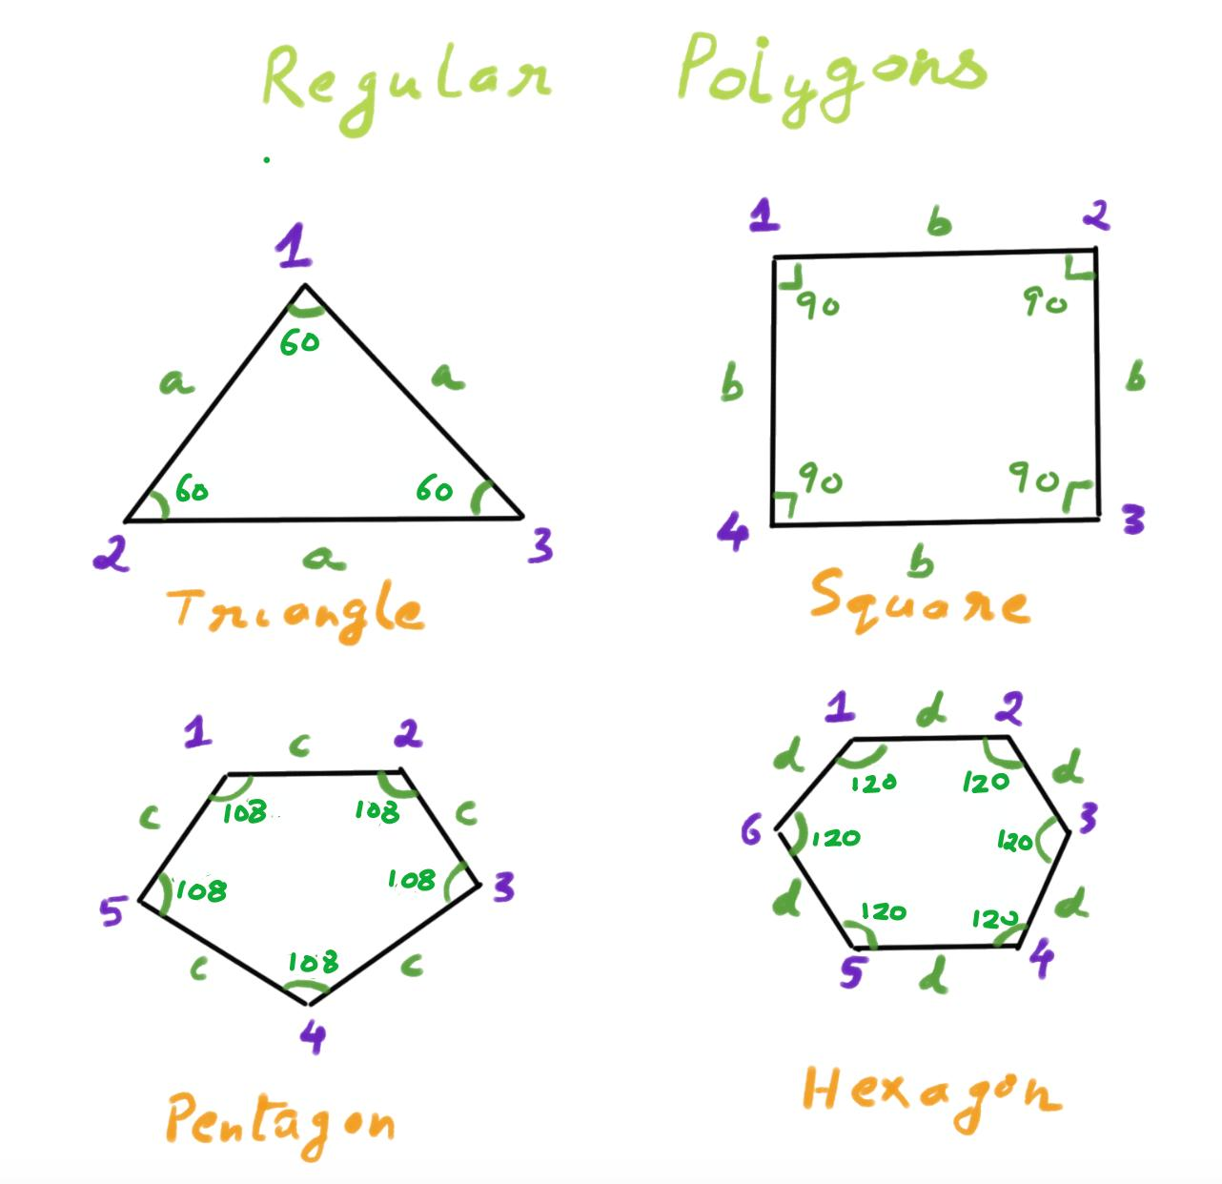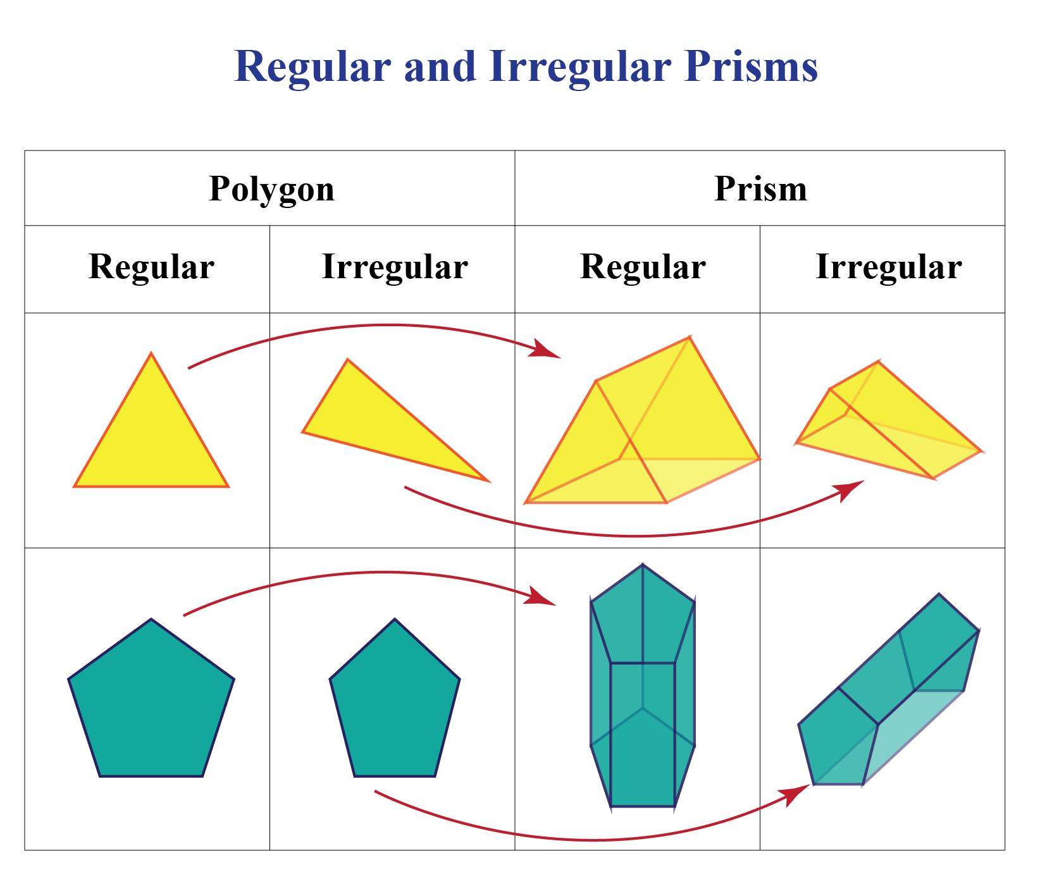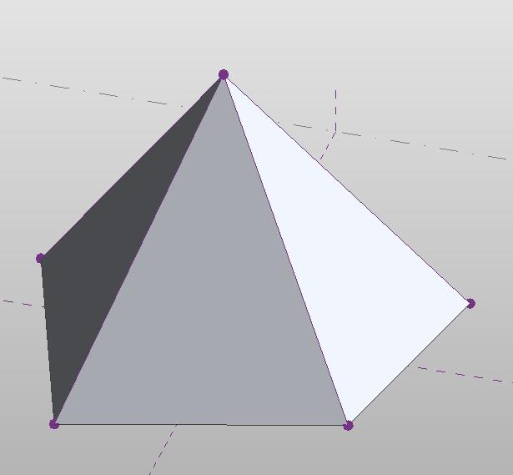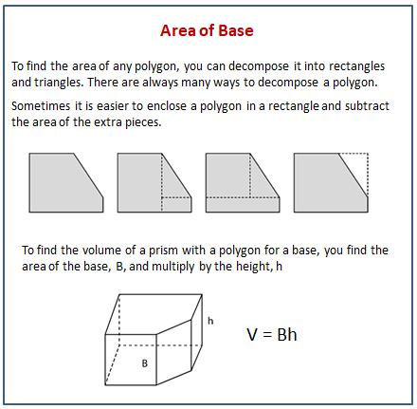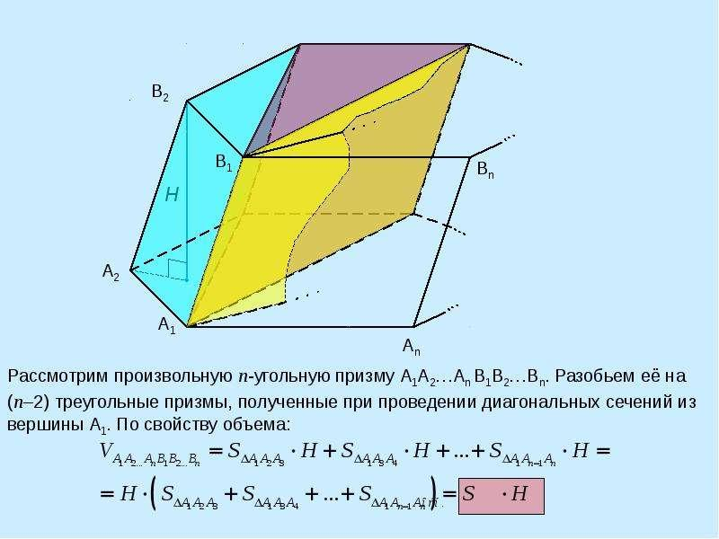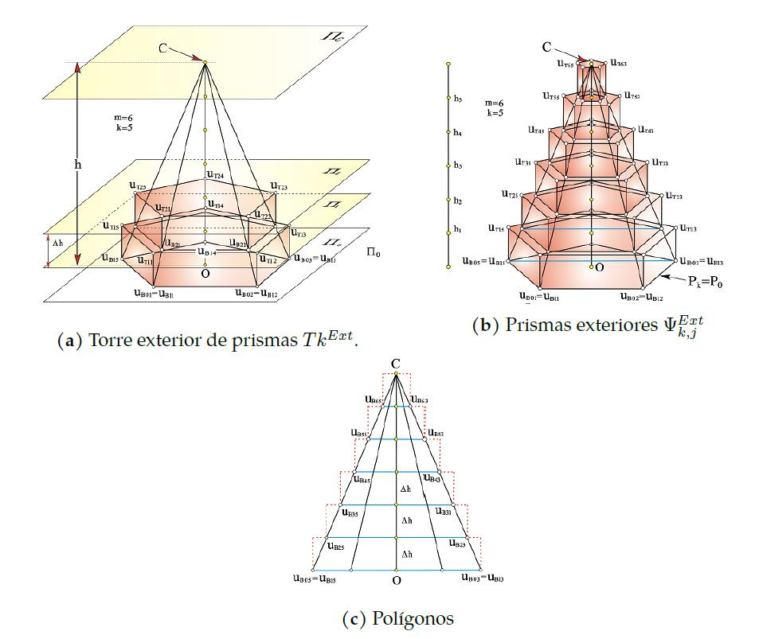

Geometric Structure
# Source: AI Source: Provided by: [Data Path: Persons Table -> ID Column: 1, Name_En Column: Motasem Essam] -> From: [ChatGPT] on [7/25/2026]
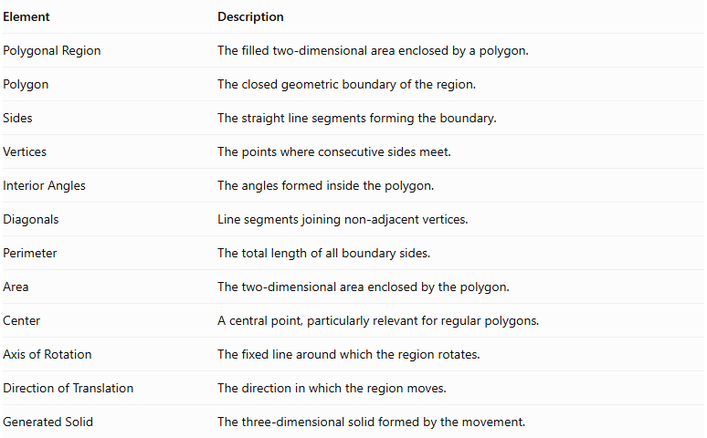
Element | Description
Polygonal Region | The filled two-dimensional area enclosed by a polygon.
Polygon | The closed geometric boundary of the region.
Sides | The straight line segments forming the boundary.
Vertices | The points where consecutive sides meet.
Interior Angles | The angles formed inside the polygon.
Diagonals | Line segments joining non-adjacent vertices.
Perimeter | The total length of all boundary sides.
Area | The two-dimensional area enclosed by the polygon.
Center | A central point, particularly relevant for regular polygons.
Axis of Rotation | The fixed line around which the region rotates.
Direction of Translation | The direction in which the region moves.
Generated Solid | The three-dimensional solid formed by the movement.

Types of Polygonal-Region Generators According to Polygon Shape
# Source: AI Source: Provided by: [Data Path: Persons Table -> ID Column: 1, Name_En Column: Motasem Essam] -> From: [ChatGPT] on [7/25/2026]
Polygonal-region generators can be classified according to the number and arrangement of their sides.

Triangular-Region Generator
# Source: AI Source: Provided by: [Data Path: Persons Table -> ID Column: 1, Name_En Column: Motasem Essam] -> From: [ChatGPT] on [7/25/2026]
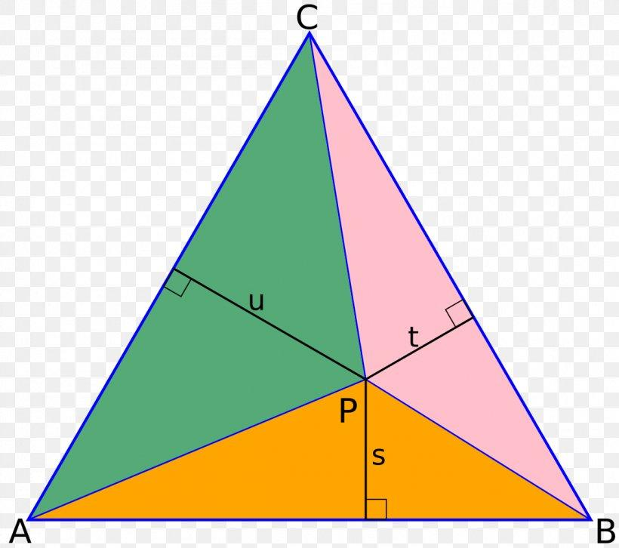
Uses a triangular region with three sides.
Common generated solids:
- Triangular Prism.
- Triangular Pyramid (Tetrahedron).
- Solids of Revolution, depending on the rotation axis.

Quadrilateral-Region Generator
# Source: AI Source: Provided by: [Data Path: Persons Table -> ID Column: 1, Name_En Column: Motasem Essam] -> From: [ChatGPT] on [7/25/2026]
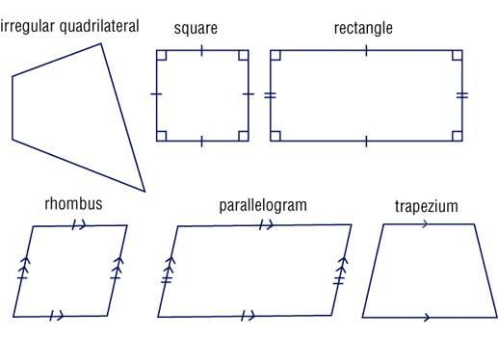
Uses a four-sided polygonal region.
Common generating figures:
- Square Region.
- Rectangular Region.
- Parallelogram Region.
- Rhombus Region.
- Trapezoidal Region.
- Kite-Shaped Region.
Common generated solids include rectangular prisms, parallelepipeds, and various solids of revolution.

Pentagonal-Region Generator
# Source: AI Source: Provided by: [Data Path: Persons Table -> ID Column: 1, Name_En Column: Motasem Essam] -> From: [ChatGPT] on [7/25/2026]
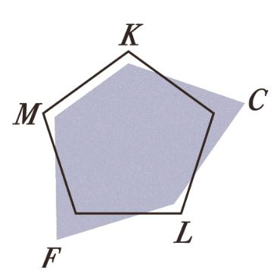
Uses a five-sided polygonal region.
Common generated solid:
- Pentagonal Prism.
- Pentagonal Pyramid.
- Solids of Revolution, depending on the axis.

Hexagonal-Region Generator
# Source: AI Source: Provided by: [Data Path: Persons Table -> ID Column: 1, Name_En Column: Motasem Essam] -> From: [ChatGPT] on [7/25/2026]
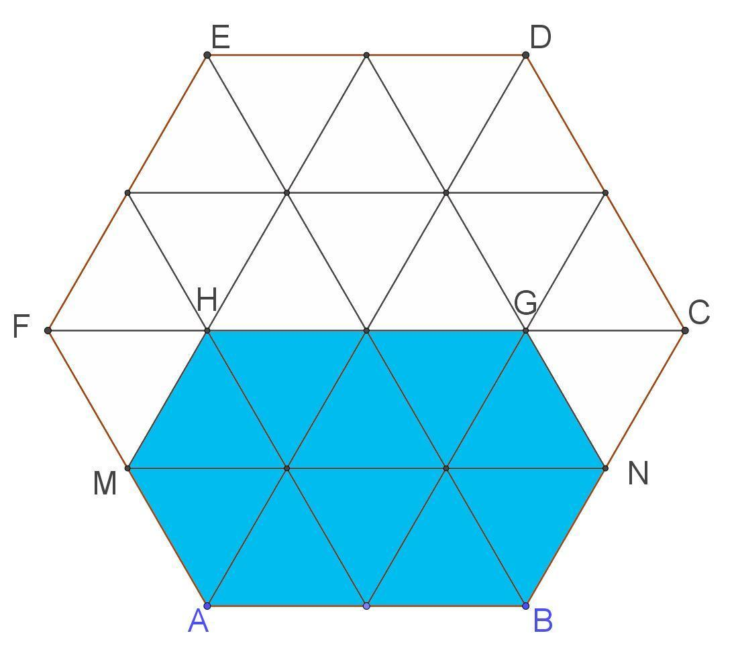
Uses a six-sided polygonal region.
Common generated solid:
- Hexagonal Prism.
- Hexagonal Pyramid.
- Solids of Revolution, depending on the axis.

Heptagonal-Region Generator
# Source: AI Source: Provided by: [Data Path: Persons Table -> ID Column: 1, Name_En Column: Motasem Essam] -> From: [ChatGPT] on [7/25/2026]
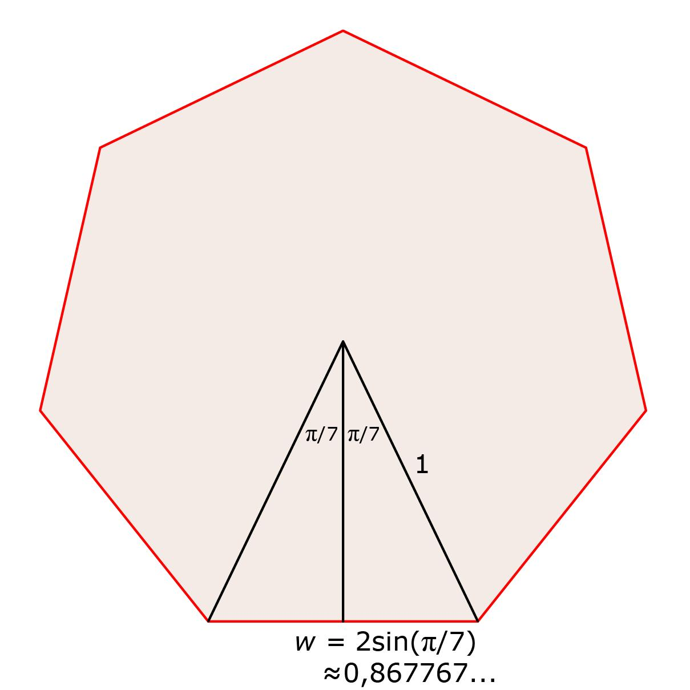
Uses a seven-sided polygonal region.
Common generated solid:
- Heptagonal Prism.
- Heptagonal Pyramid.

Octagonal-Region Generator
# Source: AI Source: Provided by: [Data Path: Persons Table -> ID Column: 1, Name_En Column: Motasem Essam] -> From: [ChatGPT] on [7/25/2026]
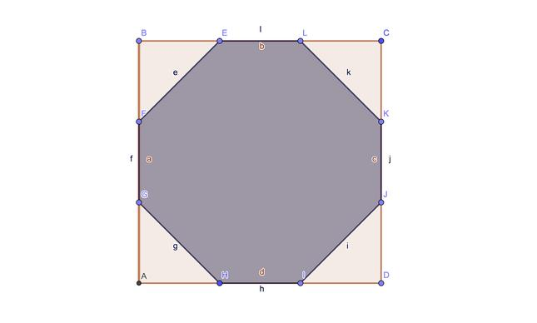
Uses an eight-sided polygonal region.
Common generated solid:
- Octagonal Prism.
- Octagonal Pyramid.

Other Polygonal-Region Generators
# Source: AI Source: Provided by: [Data Path: Persons Table -> ID Column: 1, Name_En Column: Motasem Essam] -> From: [ChatGPT] on [7/25/2026]
The classification continues for polygons with higher numbers of sides.
Examples include:
- Nonagonal-Region Generator (9 sides).
- Decagonal-Region Generator (10 sides).
- Undecagonal-Region Generator (11 sides).
- Dodecagonal-Region Generator (12 sides).
- General $n$-Gonal Region Generator.
A general polygonal region may have any finite number of sides, provided it forms a closed polygon.

Types of Polygonal Regions According to Geometric Properties

Regular Polygonal-Region Generator
# Source: AI Source: Provided by: [Data Path: Persons Table -> ID Column: 1, Name_En Column: Motasem Essam] -> From: [ChatGPT] on [7/25/2026]
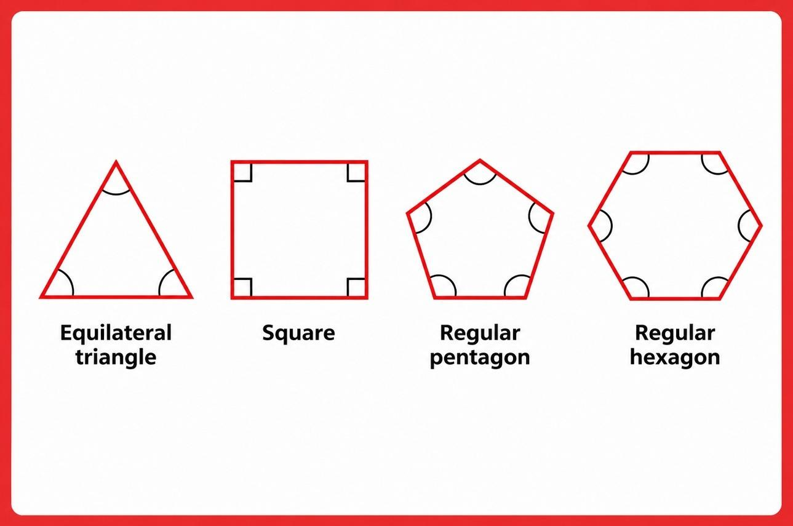
Uses a regular polygonal region whose sides are equal in length and whose interior angles are equal.
Examples:
- Equilateral Triangular Region.
- Square Region.
- Regular Pentagonal Region.
- Regular Hexagonal Region.
- Regular Heptagonal Region.
- Regular Octagonal Region.

Irregular Polygonal-Region Generator
# Source: AI Source: Provided by: [Data Path: Persons Table -> ID Column: 1, Name_En Column: Motasem Essam] -> From: [ChatGPT] on [7/25/2026]
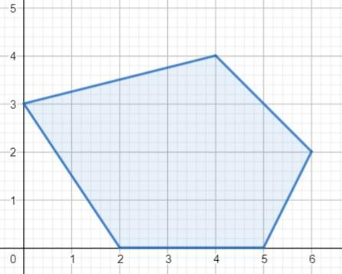
Uses an irregular polygonal region in which the sides and/or interior angles are not all equal.
Examples:
- Irregular Triangle.
- Irregular Quadrilateral.
- Irregular Pentagon.
- Irregular Hexagon.
- General Irregular Polygon.

Convex Polygonal-Region Generator
# Source: AI Source: Provided by: [Data Path: Persons Table -> ID Column: 1, Name_En Column: Motasem Essam] -> From: [ChatGPT] on [7/25/2026]
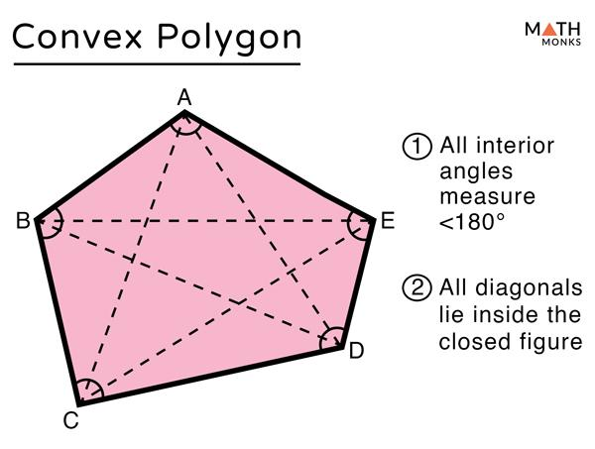
Uses a convex polygonal region in which every interior angle is less than ${180}^{∘}$, and every line segment joining two points within the region remains inside it.

Concave Polygonal-Region Generator
# Source: AI Source: Provided by: [Data Path: Persons Table -> ID Column: 1, Name_En Column: Motasem Essam] -> From: [ChatGPT] on [7/25/2026]
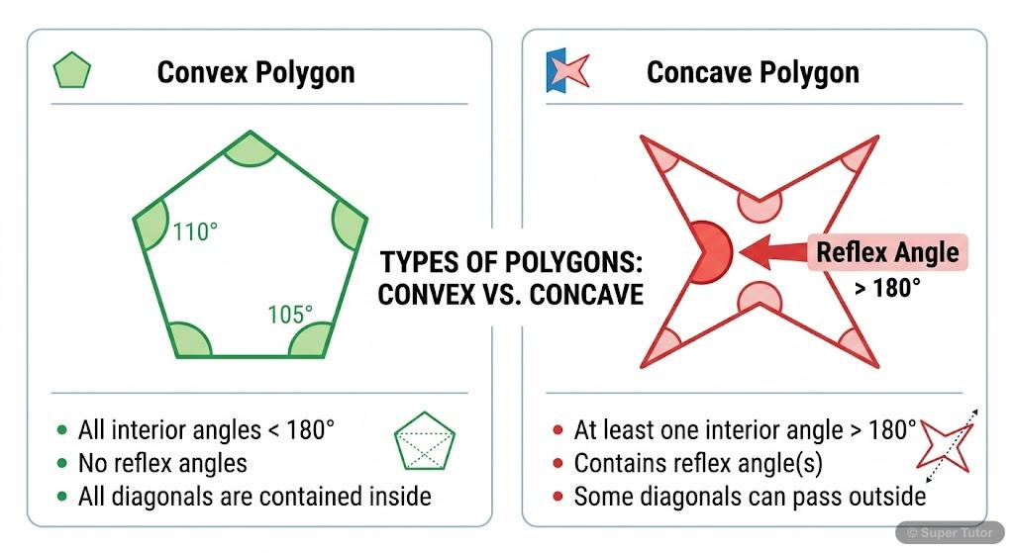
Uses a concave polygonal region containing at least one interior angle greater than ${180}^{∘}$.
Note: Regularity and convexity are separate classification criteria. A polygon can be regular and convex, or irregular and either convex or concave.

Types of Polygonal-Region Generators According to Movement

Translational Polygonal-Region Generator
# Source: AI Source: Provided by: [Data Path: Persons Table -> ID Column: 1, Name_En Column: Motasem Essam] -> From: [ChatGPT] on [7/25/2026]
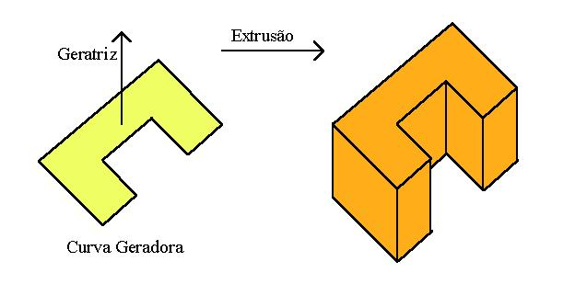
A polygonal region moves along a straight direction without changing its shape or orientation.
A. Perpendicular Translation
- Generates a Right Prism when the translation is perpendicular to the polygon's plane.
- The original polygon forms one base.
- The translated polygon forms the opposite base.
- The connecting faces are rectangles.
B. Oblique Translation
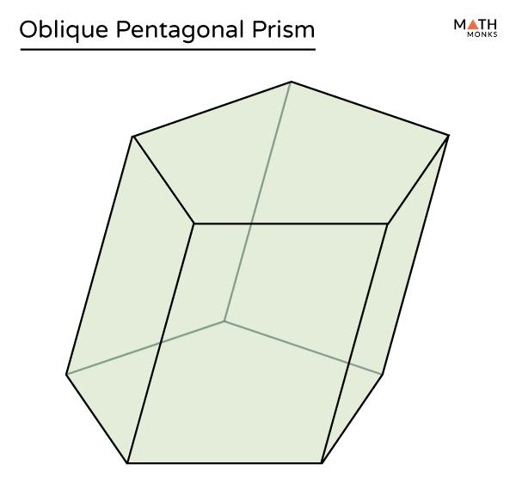
- Generates an Oblique Prism.
- The two polygonal bases remain parallel and congruent.
- The lateral faces are parallelograms.
- The translation direction is inclined relative to the base plane.

Tapered Translational Polygonal-Region Generator
# Source: AI Source: Provided by: [Data Path: Persons Table -> ID Column: 1, Name_En Column: Motasem Essam] -> From: [ChatGPT] on [7/25/2026]
A polygonal region moves while its size continuously decreases toward a common point.
This movement can generate a Pyramid.
Characteristics:
- The original polygon forms the base.
- The polygonal cross-sections become progressively smaller.
- The lateral faces meet at a common apex.
- The number of triangular lateral faces corresponds to the number of sides of the polygonal base.
For example:
- Triangular Region → Triangular Pyramid.
- Square Region → Square Pyramid.
- Pentagonal Region → Pentagonal Pyramid.
- Hexagonal Region → Hexagonal Pyramid.
A uniform linear taper toward a point produces a pyramid when the corresponding vertices converge at that point.

Rotational Polygonal-Region Generator
# Source: AI Source: Provided by: [Data Path: Persons Table -> ID Column: 1, Name_En Column: Motasem Essam] -> From: [ChatGPT] on [7/25/2026]
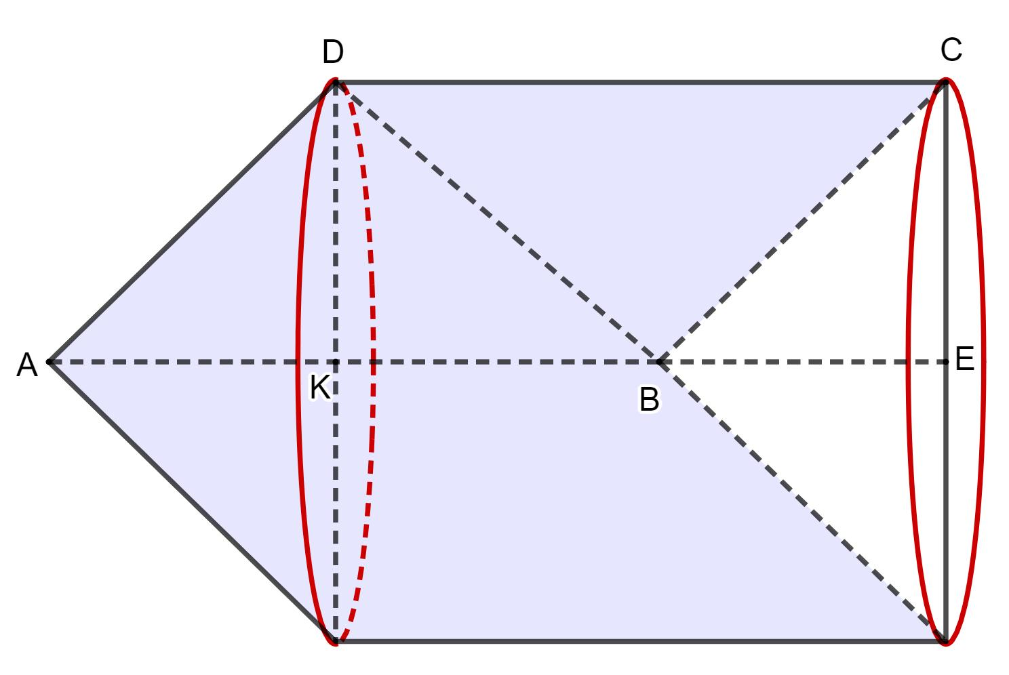
A polygonal region rotates around a fixed axis lying in its plane to generate a solid of revolution.
The generated surface is generally composed of cylindrical, conical, or planar portions, depending on the polygon's edges and their positions relative to the axis.
Examples:
- A rectangular region rotating around one of its sides generates a cylinder.
- A right-triangular region rotating around one of its perpendicular sides generates a cone.
- Other polygonal regions can generate combinations of cylindrical and conical portions.
Important: The exact generated solid depends on the selected axis and the polygon's position. Not every polygonal rotation produces a single standard solid.

General Path-Sweep Polygonal-Region Generator
# Source: AI Source: Provided by: [Data Path: Persons Table -> ID Column: 1, Name_En Column: Motasem Essam] -> From: [ChatGPT] on [7/25/2026]
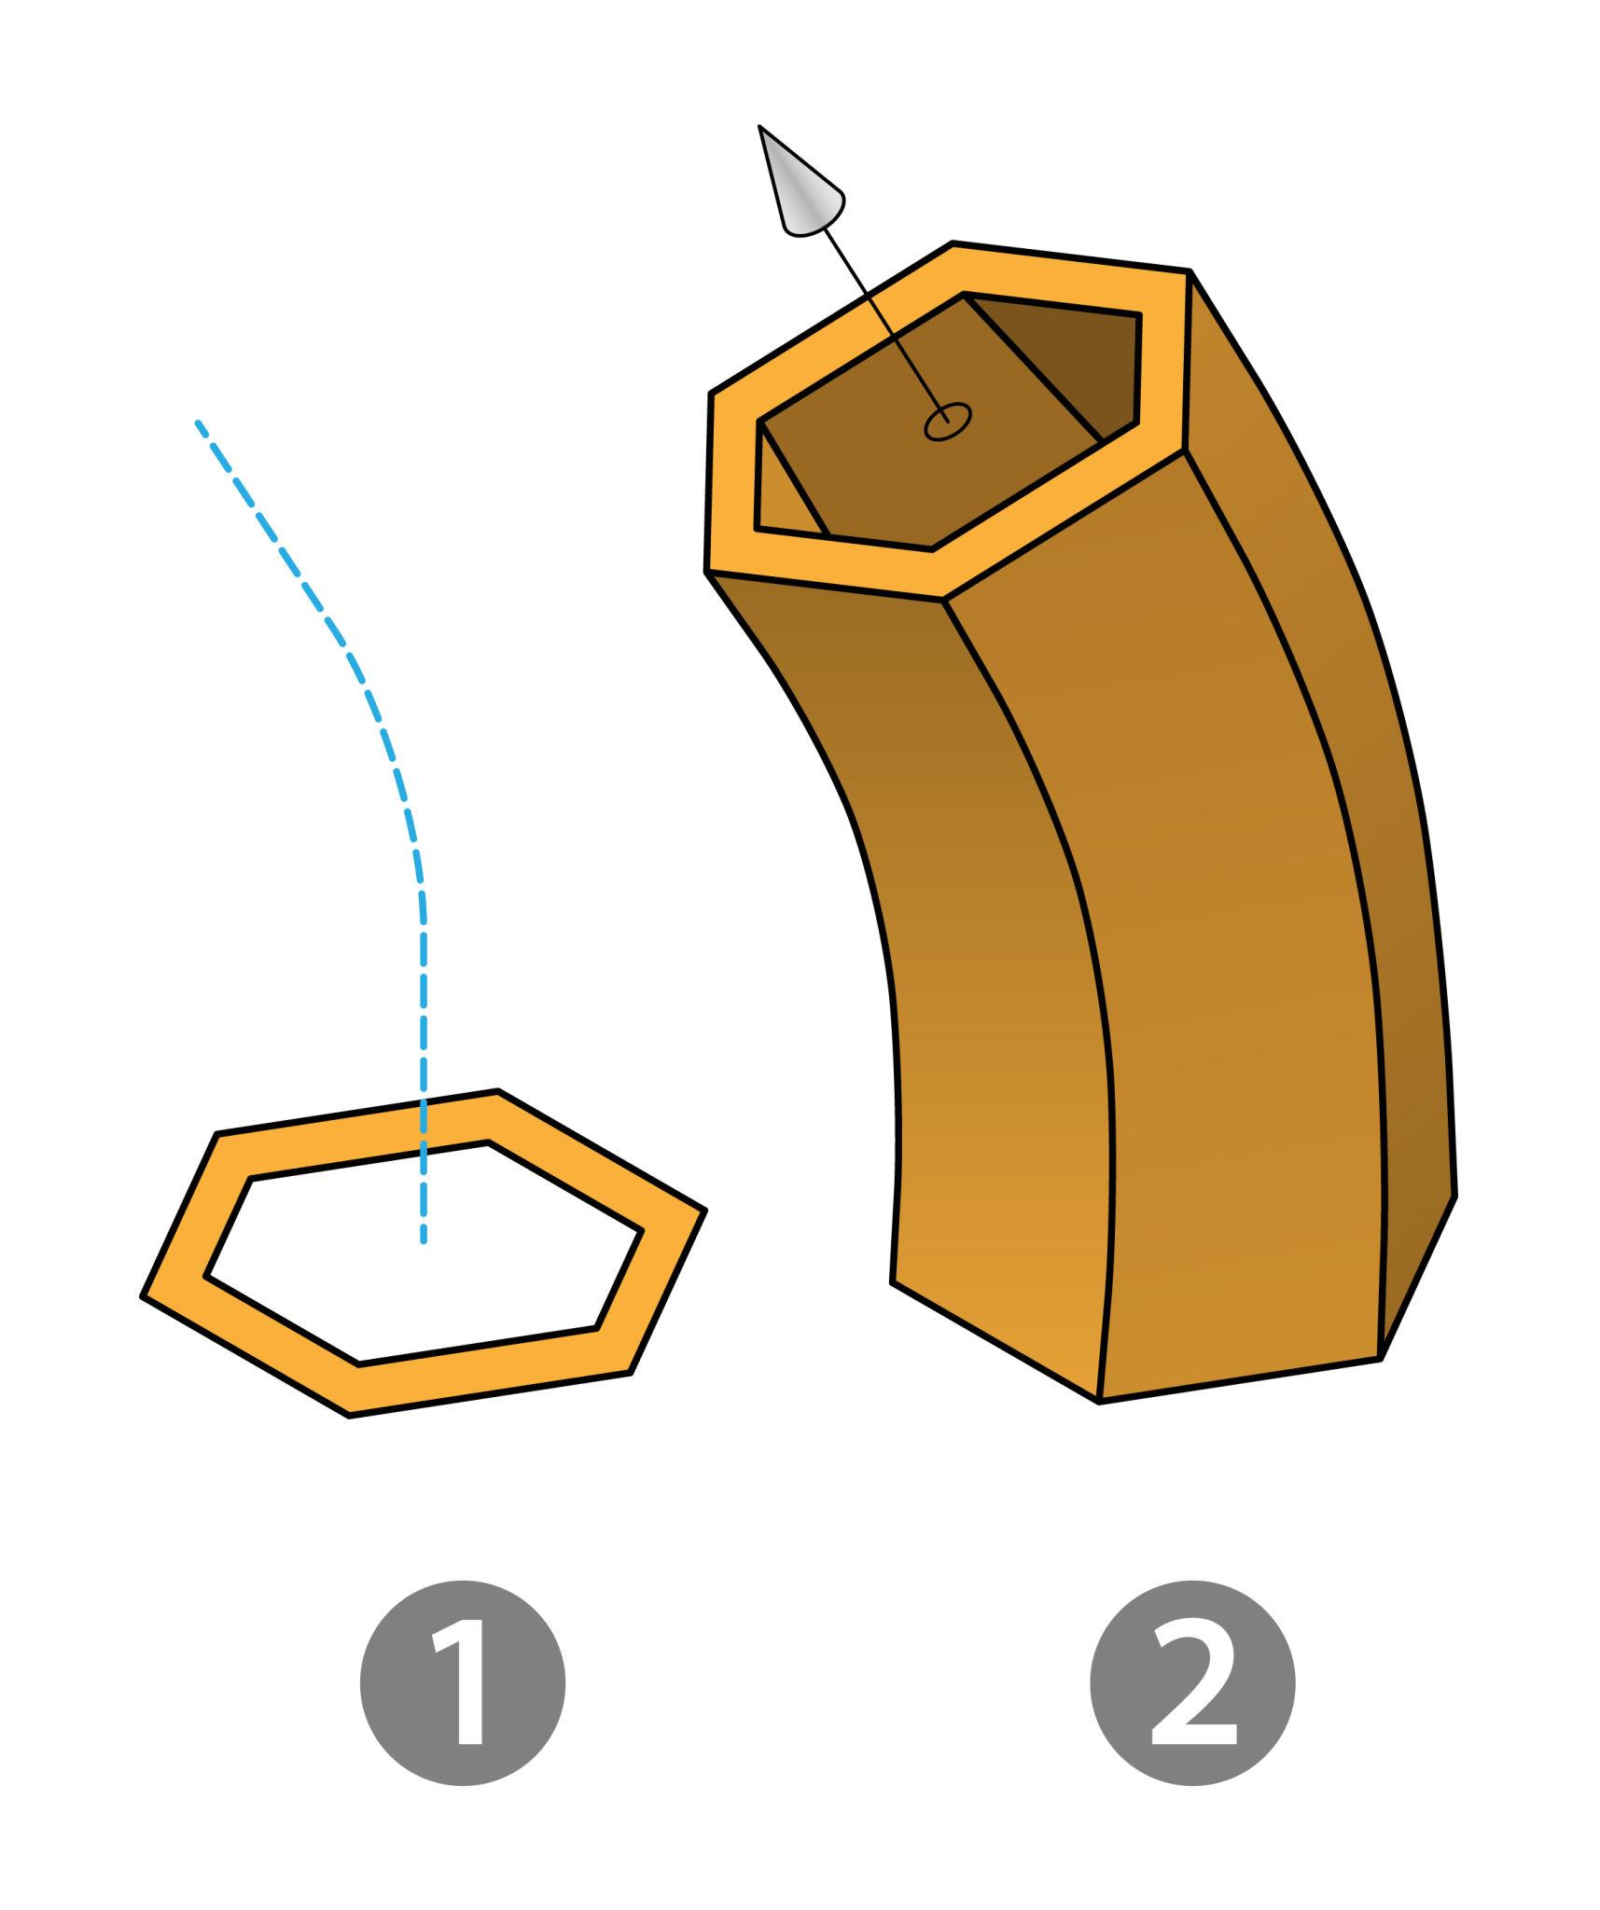
A polygonal region moves along a straight or curved path to generate a swept solid.
Characteristics:
- The polygon acts as the cross-section.
- The path determines the overall shape.
- The cross-section may maintain its orientation or rotate along the path.
- The resulting solid may be straight, curved, twisted, or more complex.
Examples include polygonal-section beams, curved structural members, and swept mechanical components.

Mathematical Representation

General Polygonal Region
# Source: AI Source: Provided by: [Data Path: Persons Table -> ID Column: 1, Name_En Column: Motasem Essam] -> From: [ChatGPT] on [7/25/2026]
Let a polygon have $n$ vertices:
$$P_{1}(x_{1},y_{1}),P_{2}(x_{2},y_{2}),…,P_{n}(x_{n},y_{n})$$
The number of sides is:
$$n≥3$$
Sum of interior angles:
$$S=(n-2){180}^{∘}$$
Number of diagonals:
$$D=\frac{n(n-3)}{2}$$
Perimeter:
$$P=\sum_{i=1}^{n}{s_{i}}$$
Where $s_{i}$ represents the length of each side.
Area using the Shoelace Formula:
$$A=\frac{1}{2}\left|\sum_{i=1}^{n}{(x_{i}y_{i+1}-x_{i+1}y_{i})}\right|$$
With the final vertex connected back to the first vertex.

Regular Polygonal Region
# Source: AI Source: Provided by: [Data Path: Persons Table -> ID Column: 1, Name_En Column: Motasem Essam] -> From: [ChatGPT] on [7/25/2026]
For a regular polygon with $n$ sides, side length $s$, and apothem $a_{p}$:
Perimeter:
$$P=ns$$
Area:
$$A=\frac{1}{2}{Pa}_{p}$$
Or:
$$A=\frac{{ns}^{2}}{4tan(π/n)}$$
Interior angle:
$$α=\frac{(n-2){180}^{∘}}{n}$$
Exterior angle:
$$β=\frac{{360}^{∘}}{n}$$

Translational Generation — Prism
# Source: AI Source: Provided by: [Data Path: Persons Table -> ID Column: 1, Name_En Column: Motasem Essam] -> From: [ChatGPT] on [7/25/2026]
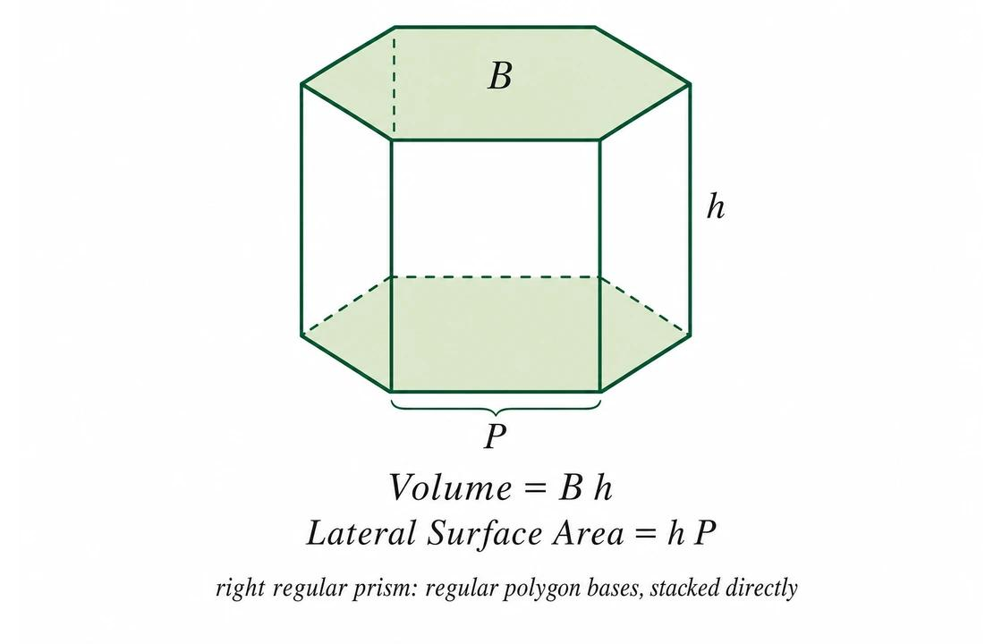
When a polygonal region is translated through a perpendicular distance $h$, it generates a right prism.
Volume:
$$V=Ah$$
Where:
- $A$ = area of the polygonal base.
- $h$ = perpendicular height of the prism.
For a right prism:
$$A_{\text{lateral}}=Ph$$
$$A_{\text{total}}=2A+Ph$$
Where $P$ is the perimeter of the polygonal base.
For an oblique prism, the volume remains $Ah$, but the lateral surface area generally differs from $Ph$.

Tapered Generation — Pyramid
# Source: AI Source: Provided by: [Data Path: Persons Table -> ID Column: 1, Name_En Column: Motasem Essam] -> From: [ChatGPT] on [7/25/2026]
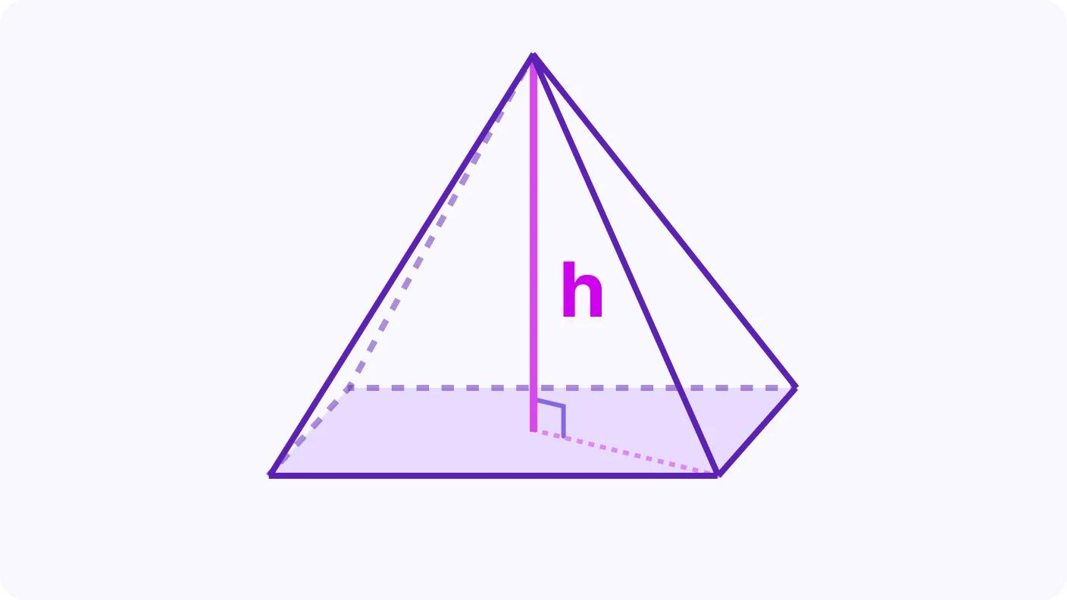
When a polygonal region tapers toward an apex, it generates a pyramid.
Volume:
$$V=\frac{1}{3}Ah$$
Where:
- $A$ = area of the polygonal base.
- $h$ = perpendicular height from the apex to the base plane.

Rotational Generation
# Source: AI Source: Provided by: [Data Path: Persons Table -> ID Column: 1, Name_En Column: Motasem Essam] -> From: [ChatGPT] on [7/25/2026]
For a polygonal region rotated around an axis in its plane, the volume can be determined using the Pappus centroid theorem when its conditions are satisfied:
$$V=2πdA$$
Where:
- $A$ = area of the generating polygonal region.
- $d$ = distance traveled by the region's centroid during one complete revolution.
The axis must not pass through the interior of the generating region for the standard theorem to apply without additional treatment.

Mathematical Properties
# Source: AI Source: Provided by: [Data Path: Persons Table -> ID Column: 1, Name_En Column: Motasem Essam] -> From: [ChatGPT] on [7/25/2026]
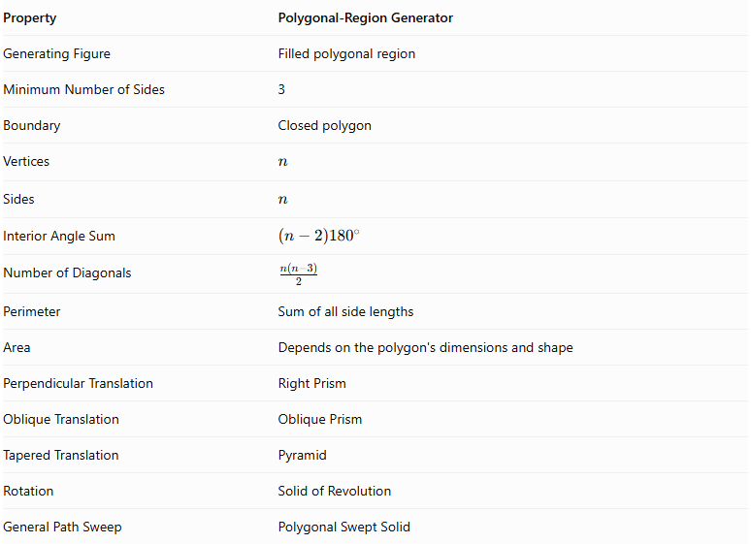
Property | Polygonal-Region Generator
Generating Figure | Filled polygonal region
Minimum Number of Sides | 3
Boundary | Closed polygon
Vertices | $$n$$
Sides | $$n$$
Interior Angle Sum | $$(n-2){180}^{∘}$$
Number of Diagonals | $$\frac{n(n-3)}{2}$$
Perimeter | Sum of all side lengths
Area | Depends on the polygon's dimensions and shape
Perpendicular Translation | Right Prism
Oblique Translation | Oblique Prism
Tapered Translation | Pyramid
Rotation | Solid of Revolution
General Path Sweep | Polygonal Swept Solid

Generated Surfaces and Solids

Polygonal Prisms
# Source: AI Source: Provided by: [Data Path: Persons Table -> ID Column: 1, Name_En Column: Motasem Essam] -> From: [ChatGPT] on [7/25/2026]
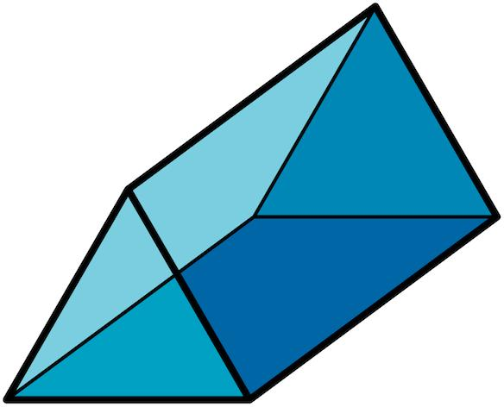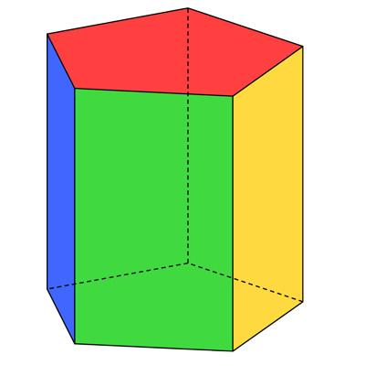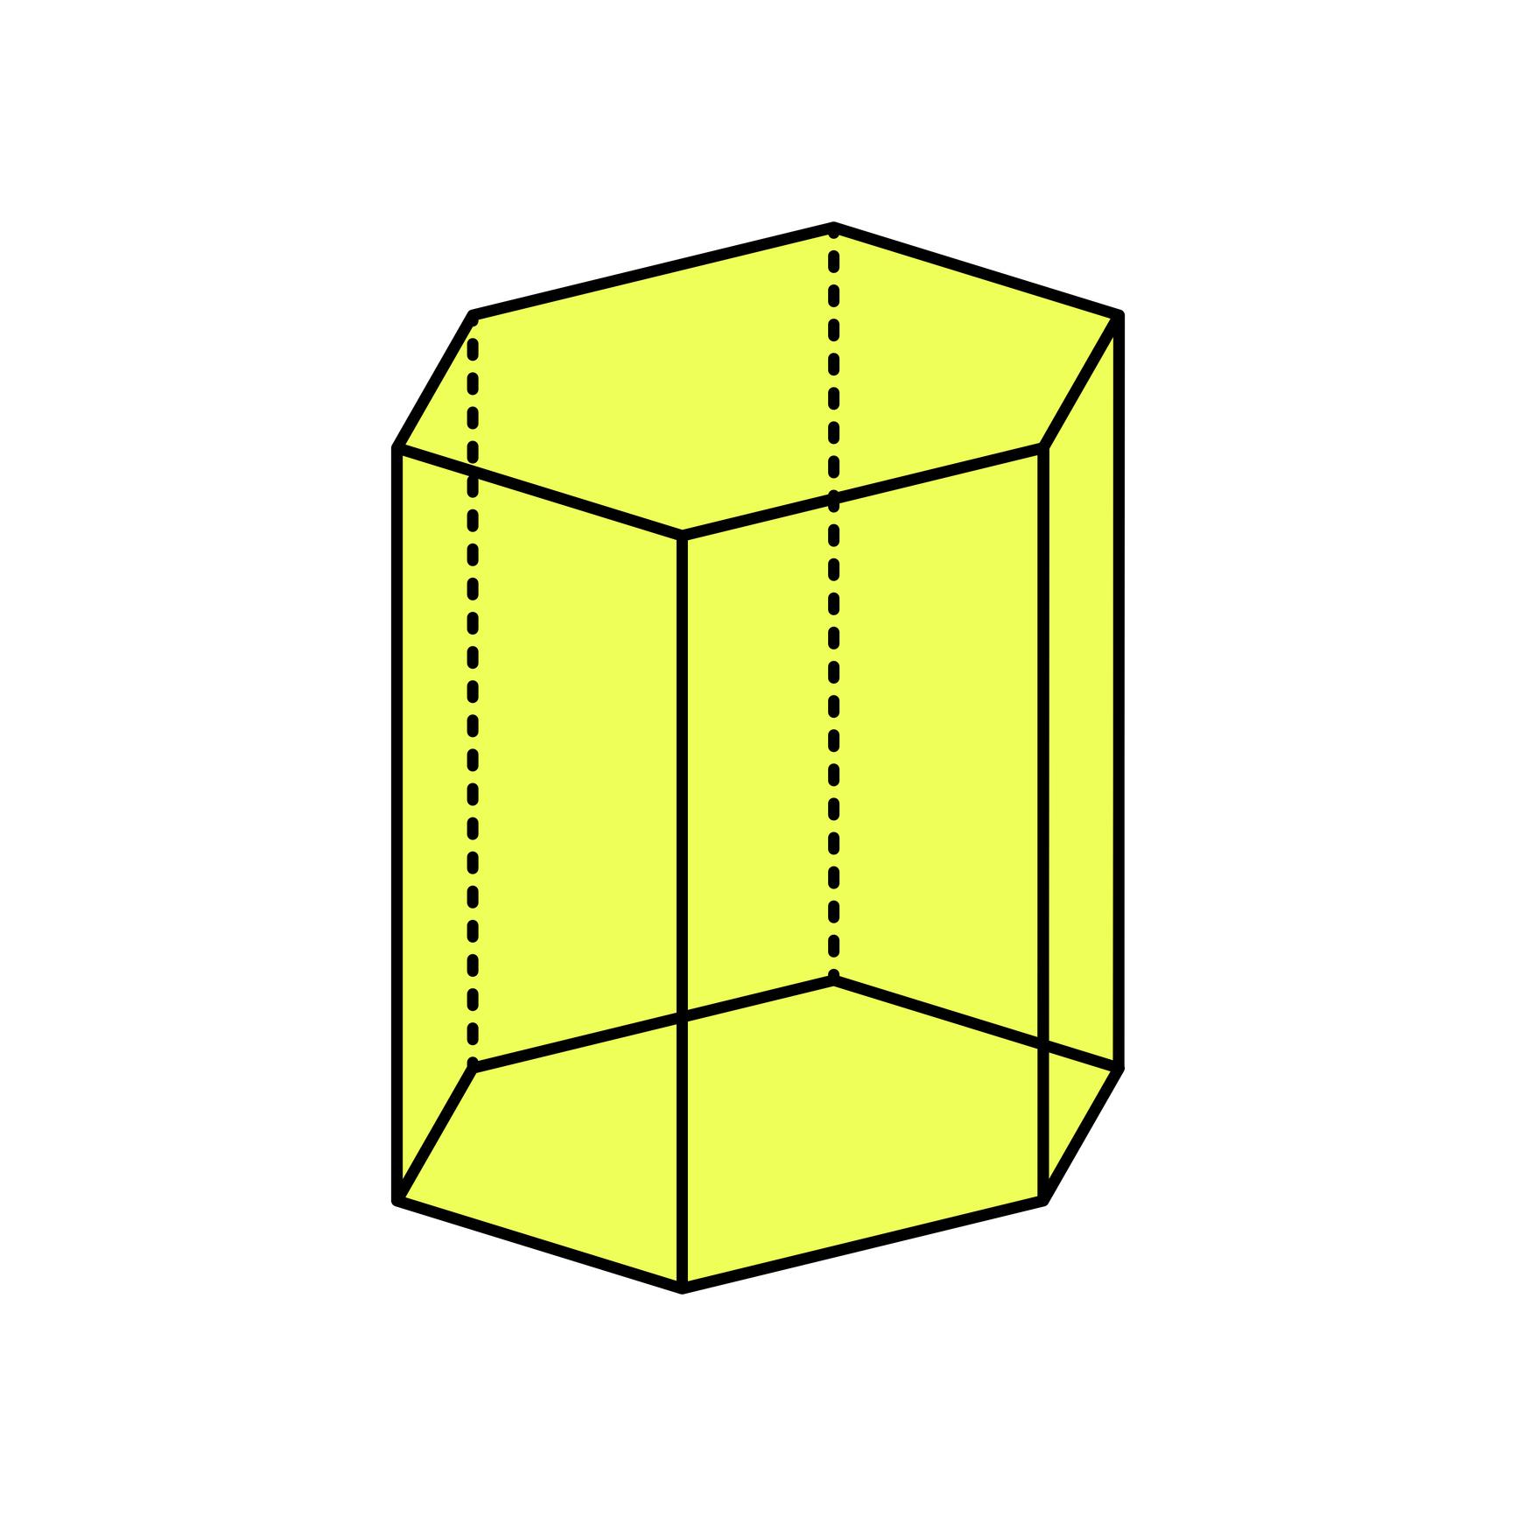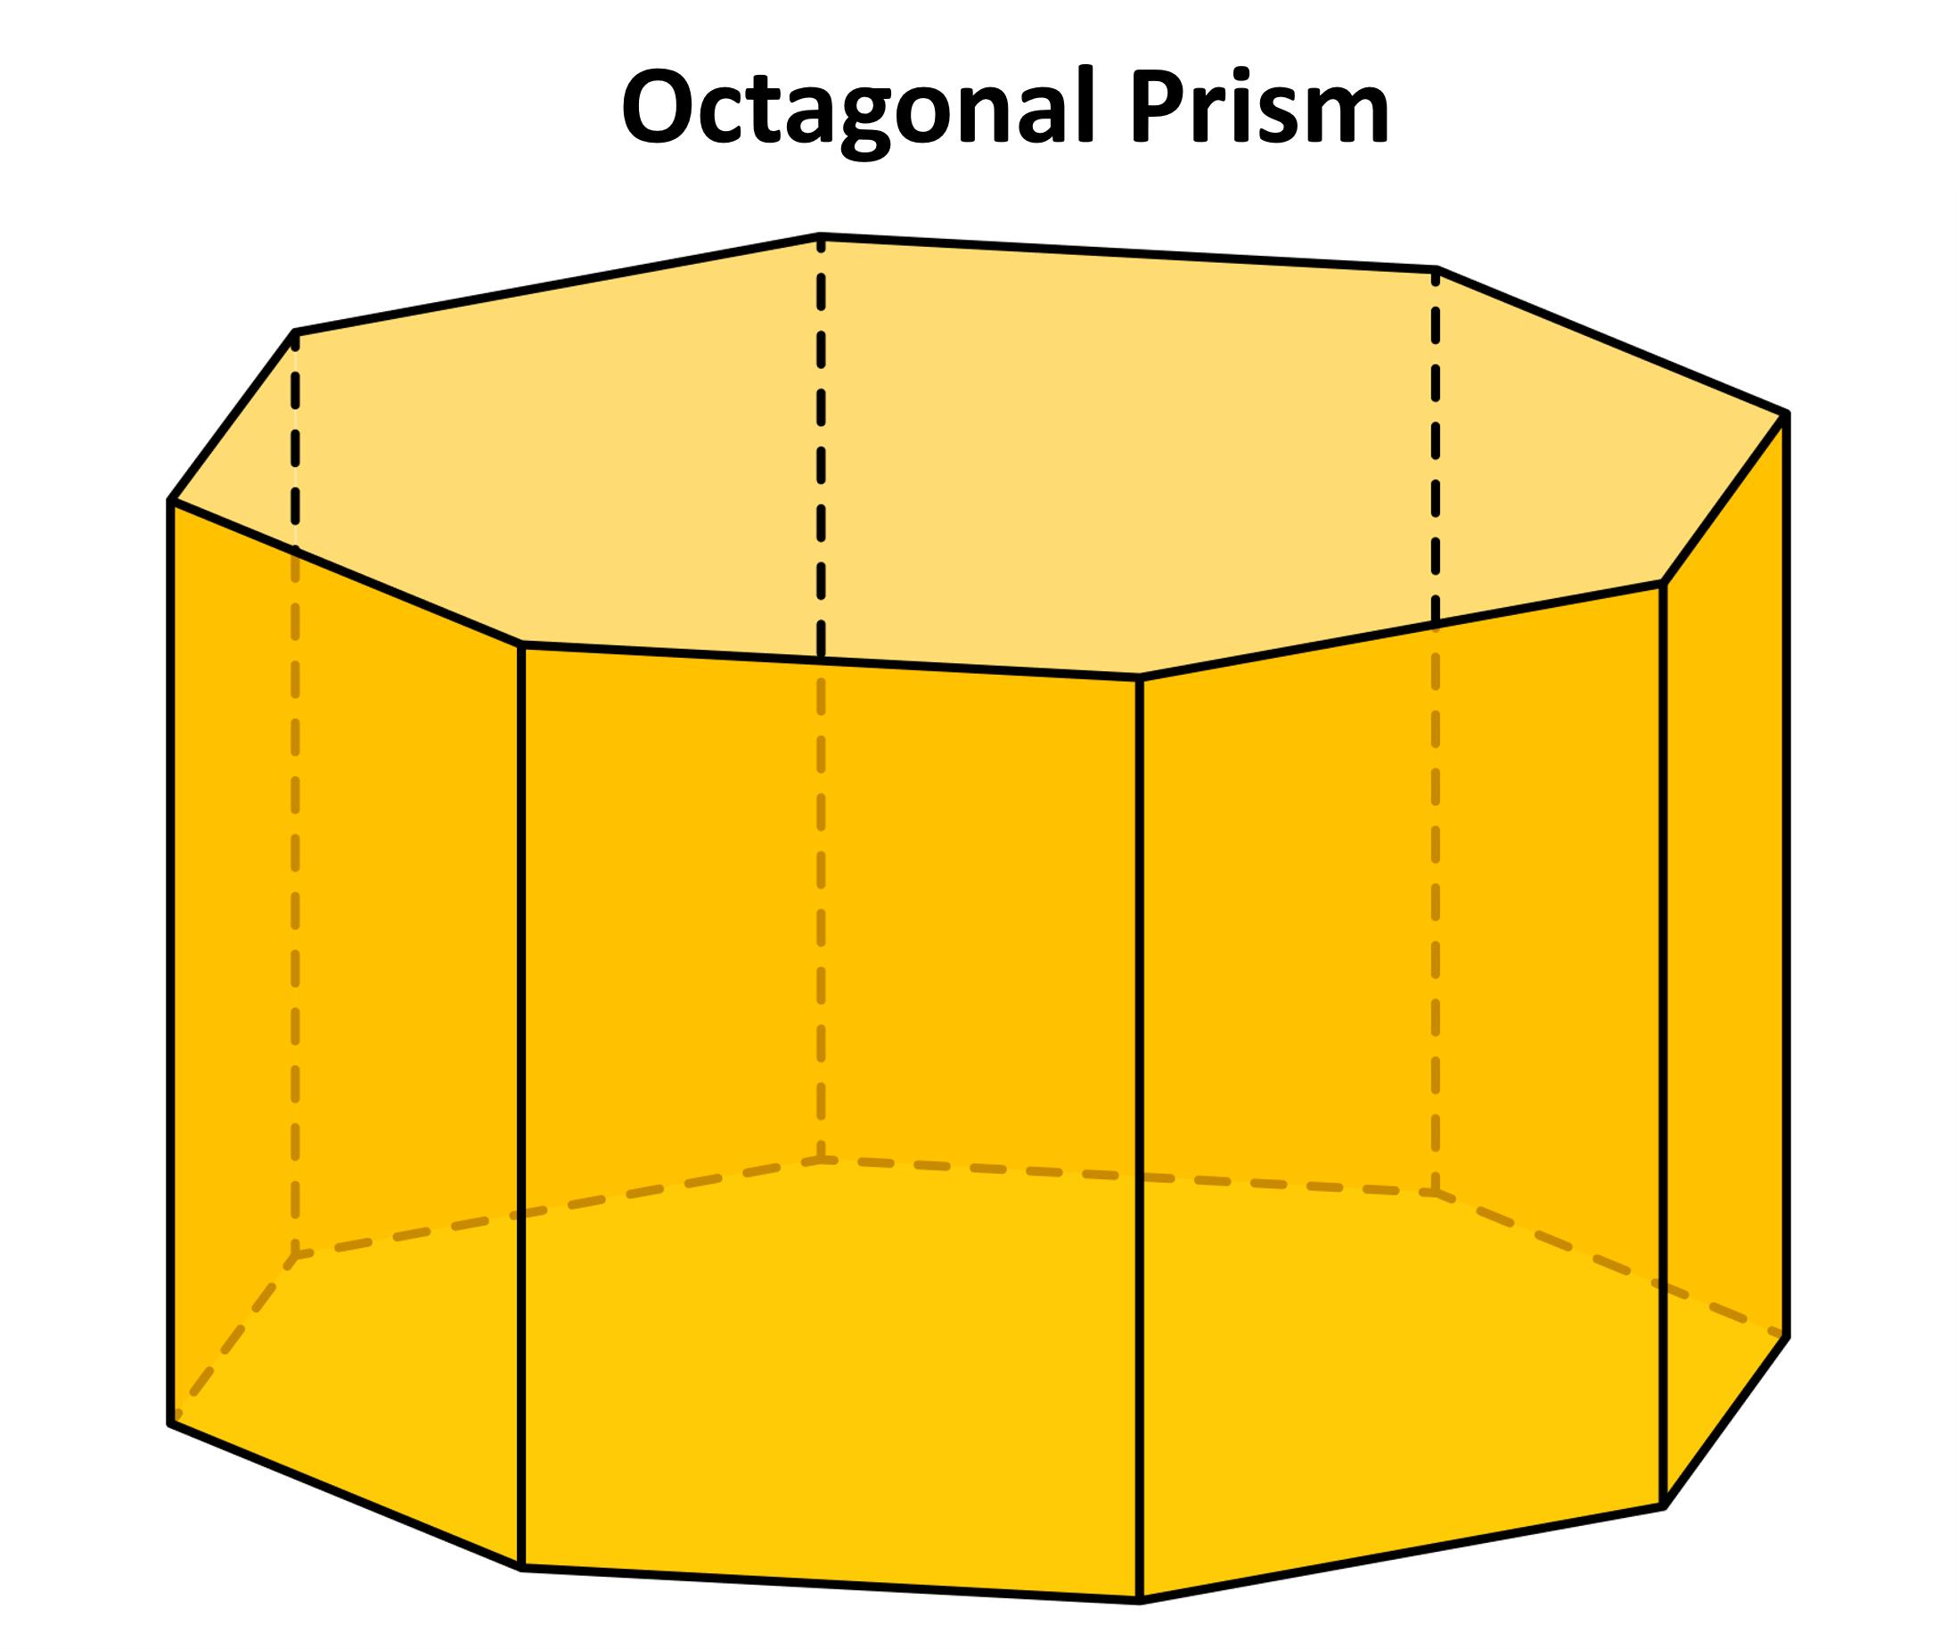
Generated by translating polygonal regions along a straight direction.
Examples:
- Triangular Prism.
- Square Prism.
- Pentagonal Prism.
- Hexagonal Prism.
- Heptagonal Prism.
- Octagonal Prism.
- General $n$-Gonal Prism.

Polygonal Pyramids
# Source: AI Source: Provided by: [Data Path: Persons Table -> ID Column: 1, Name_En Column: Motasem Essam] -> From: [ChatGPT] on [7/25/2026]
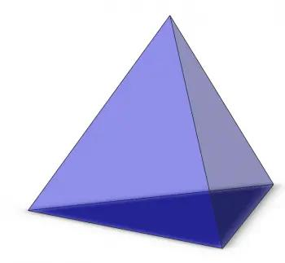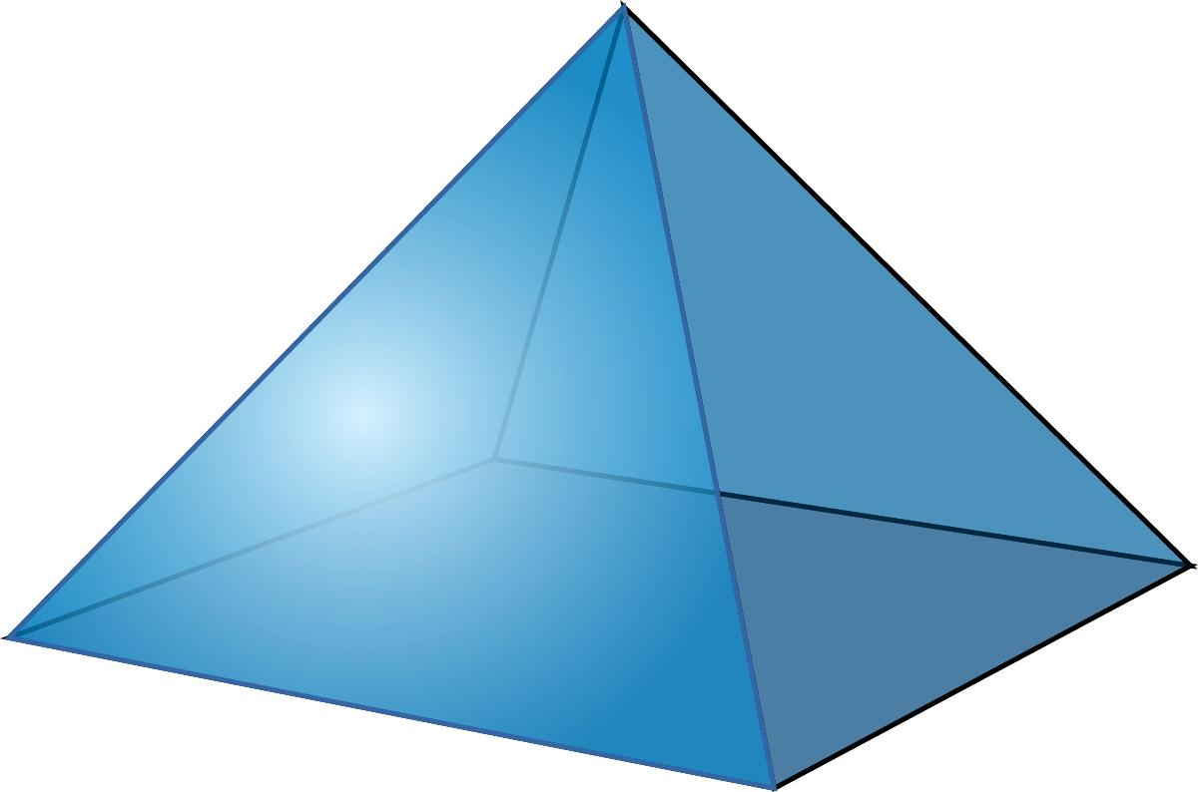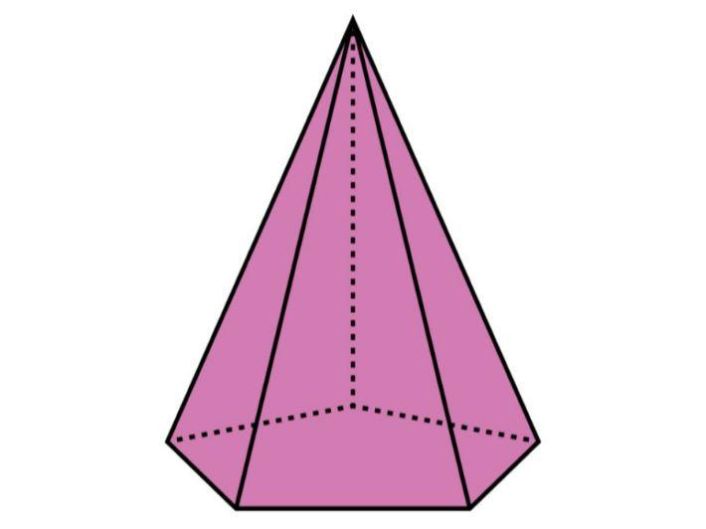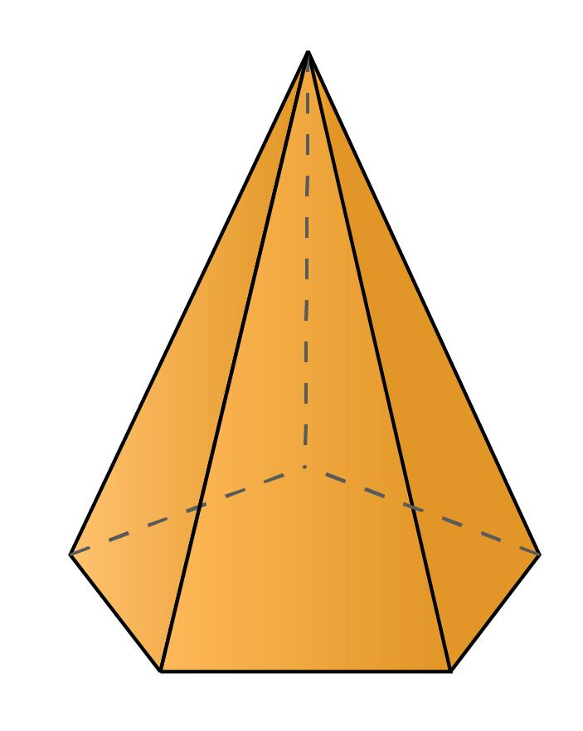
Generated by tapering polygonal regions toward a common apex.
Examples:
- Triangular Pyramid.
- Square Pyramid.
- Pentagonal Pyramid.
- Hexagonal Pyramid.
- Heptagonal Pyramid.
- Octagonal Pyramid.
- General $n$-Gonal Pyramid.

Solids of Revolution
# Source: AI Source: Provided by: [Data Path: Persons Table -> ID Column: 1, Name_En Column: Motasem Essam] -> From: [ChatGPT] on [7/25/2026]
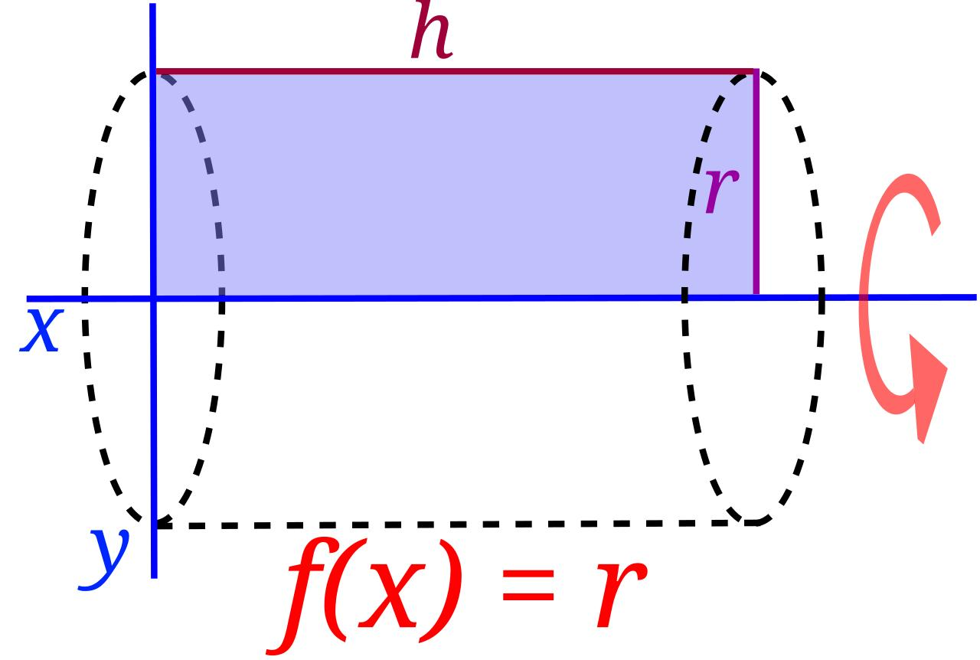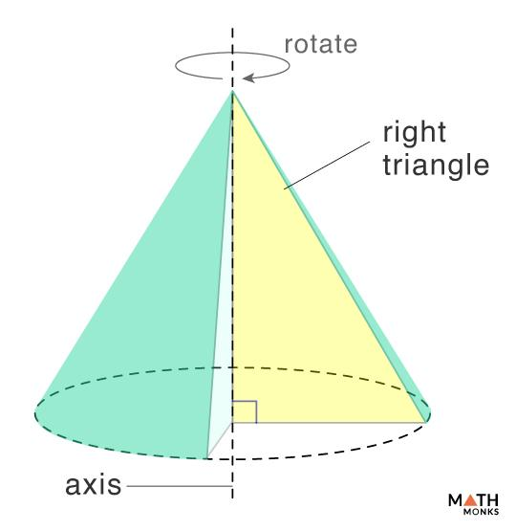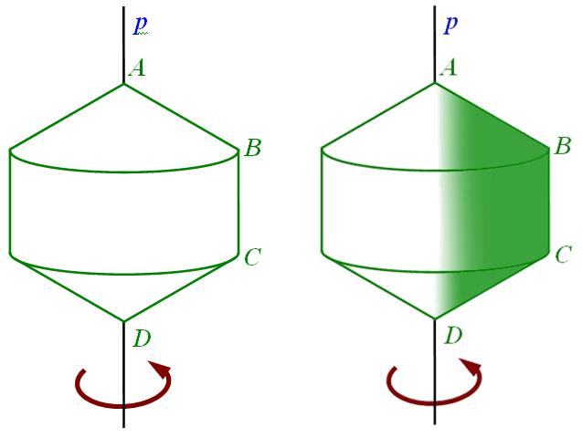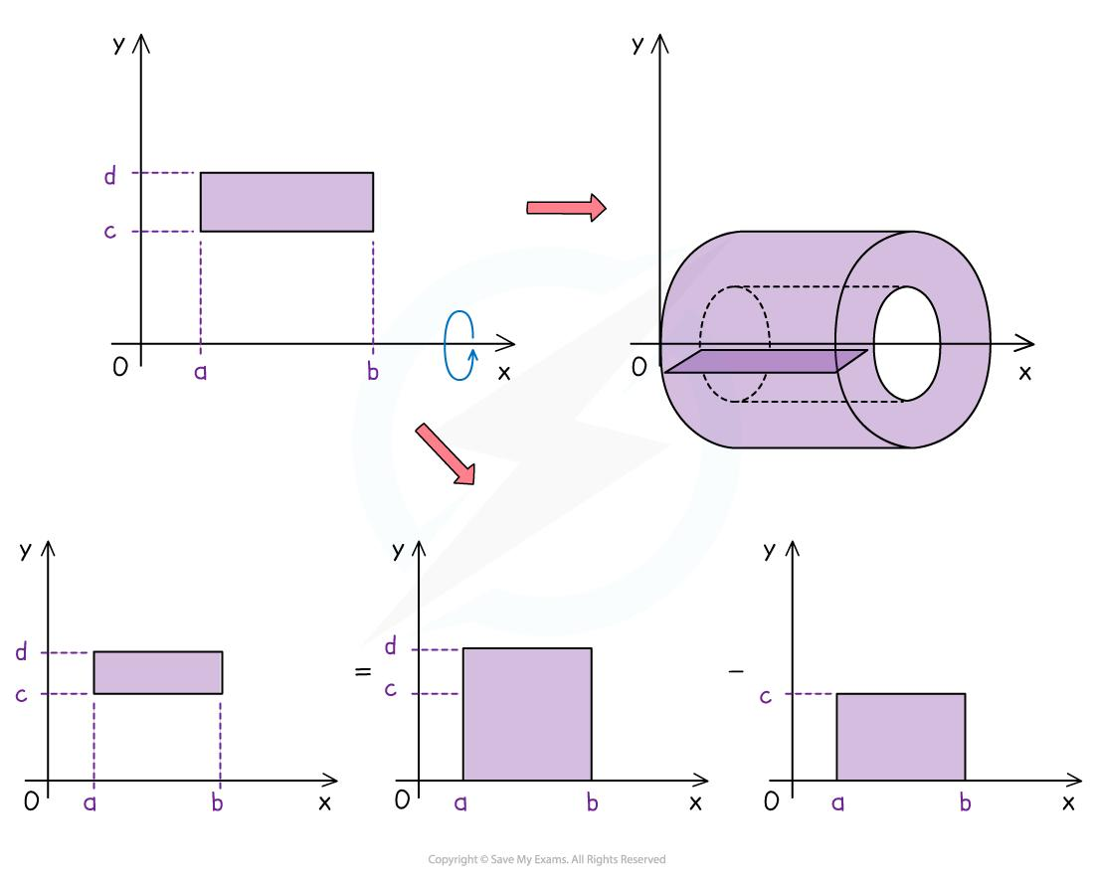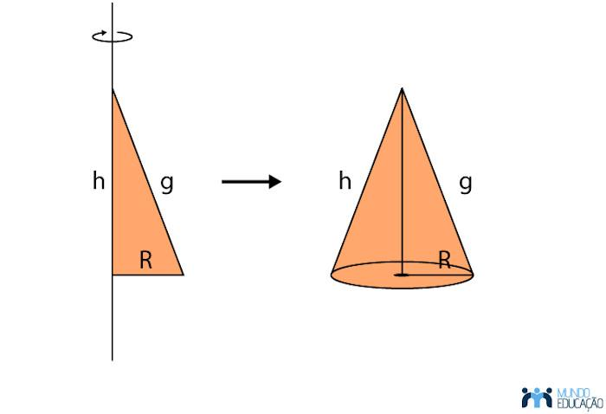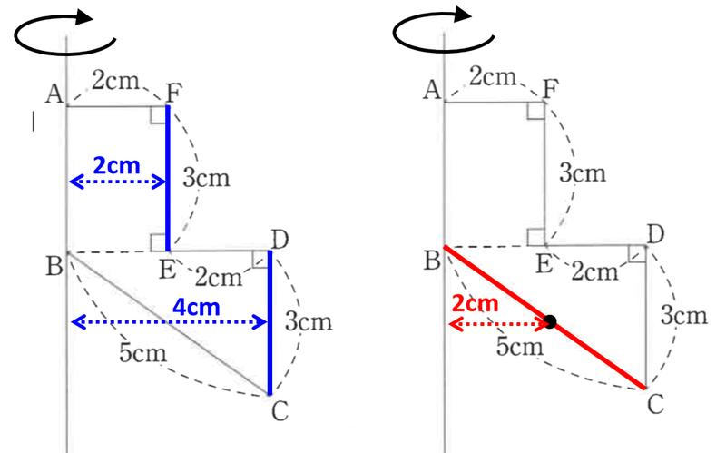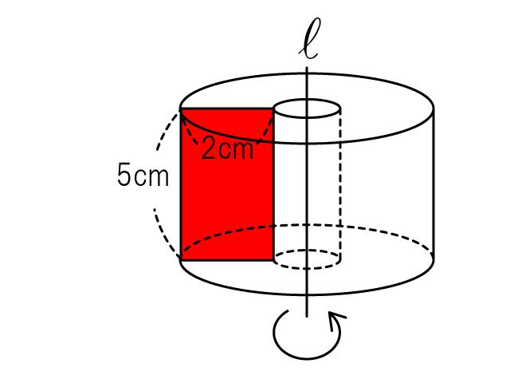
Generated by rotating polygonal regions around axes in their planes.
Examples:
- Cylinders.
- Cones.
- Composite Solids of Revolution.

General Polygonal Swept Solids
# Source: AI Source: Provided by: [Data Path: Persons Table -> ID Column: 1, Name_En Column: Motasem Essam] -> From: [ChatGPT] on [7/25/2026]
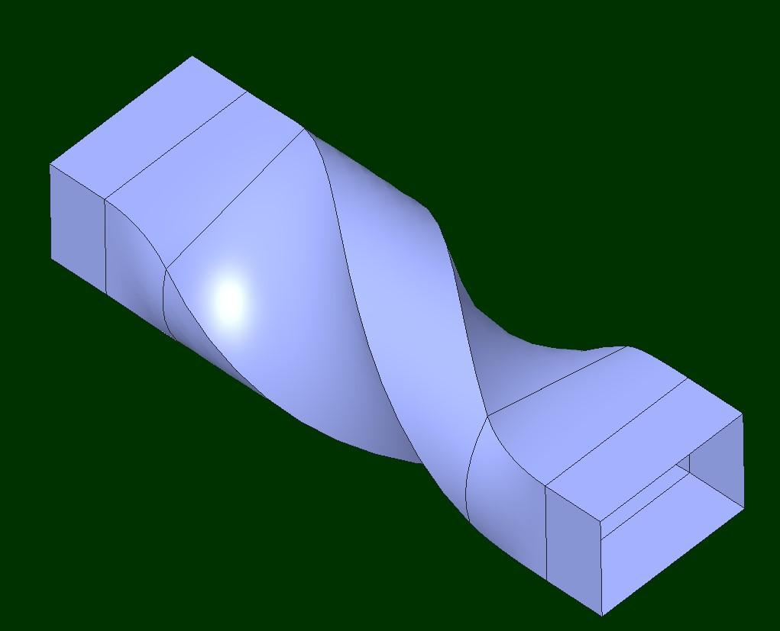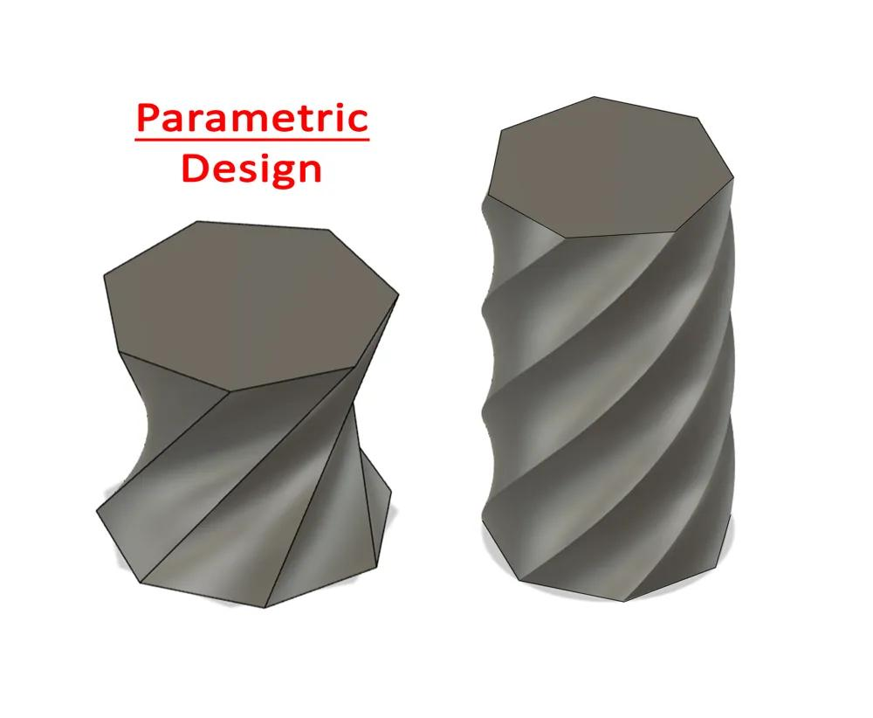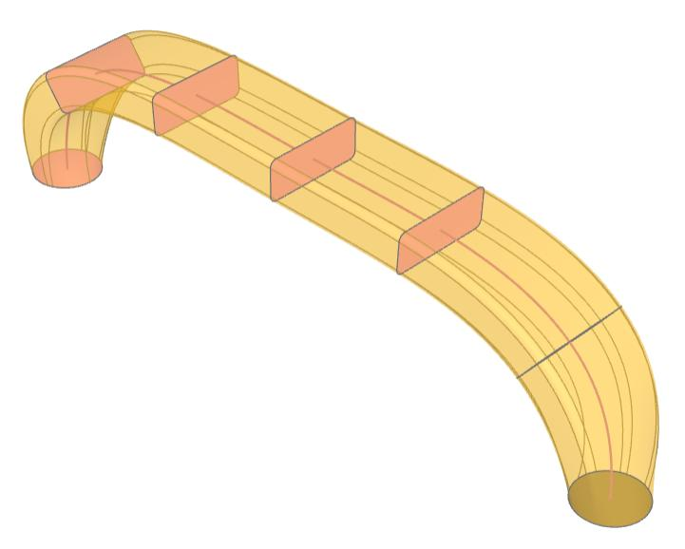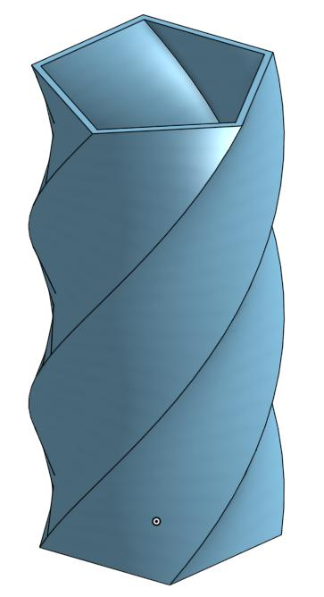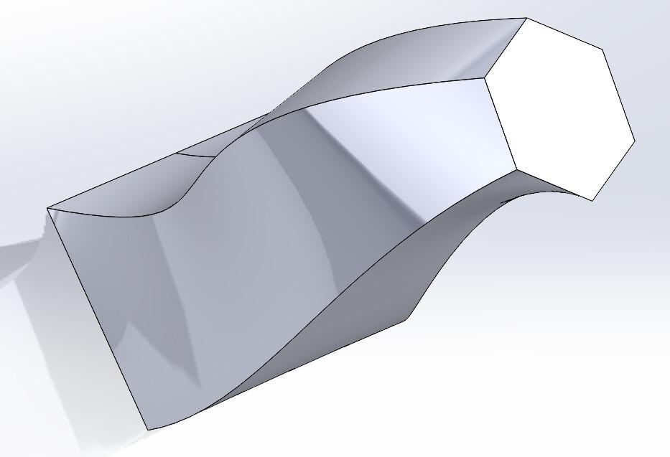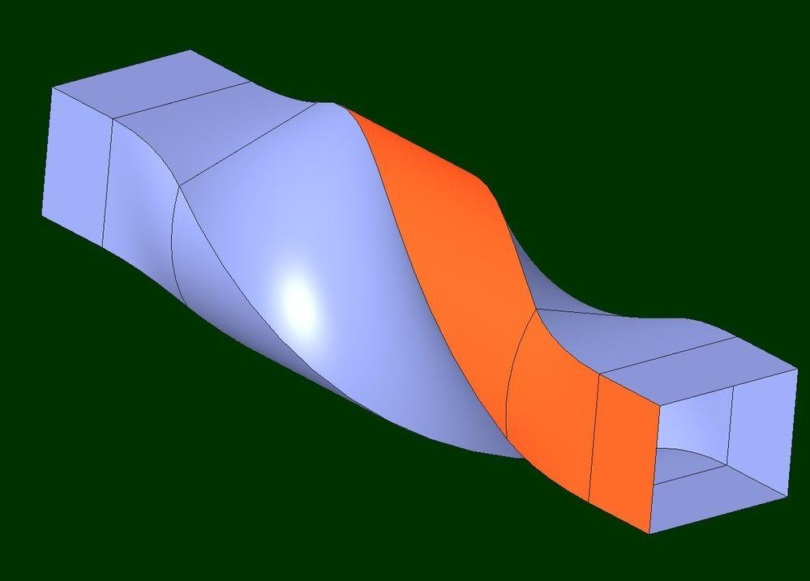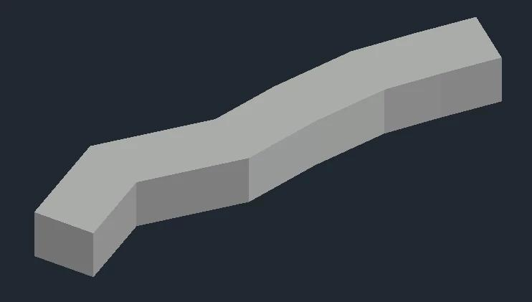
Generated by moving polygonal regions along general paths.
Examples:
- Curved Polygonal-Section Solids.
- Twisted Polygonal Extrusions.
- Complex Polygonal Swept Solids.

Applications
# Source: AI Source: Provided by: [Data Path: Persons Table -> ID Column: 1, Name_En Column: Motasem Essam] -> From: [ChatGPT] on [7/25/2026]
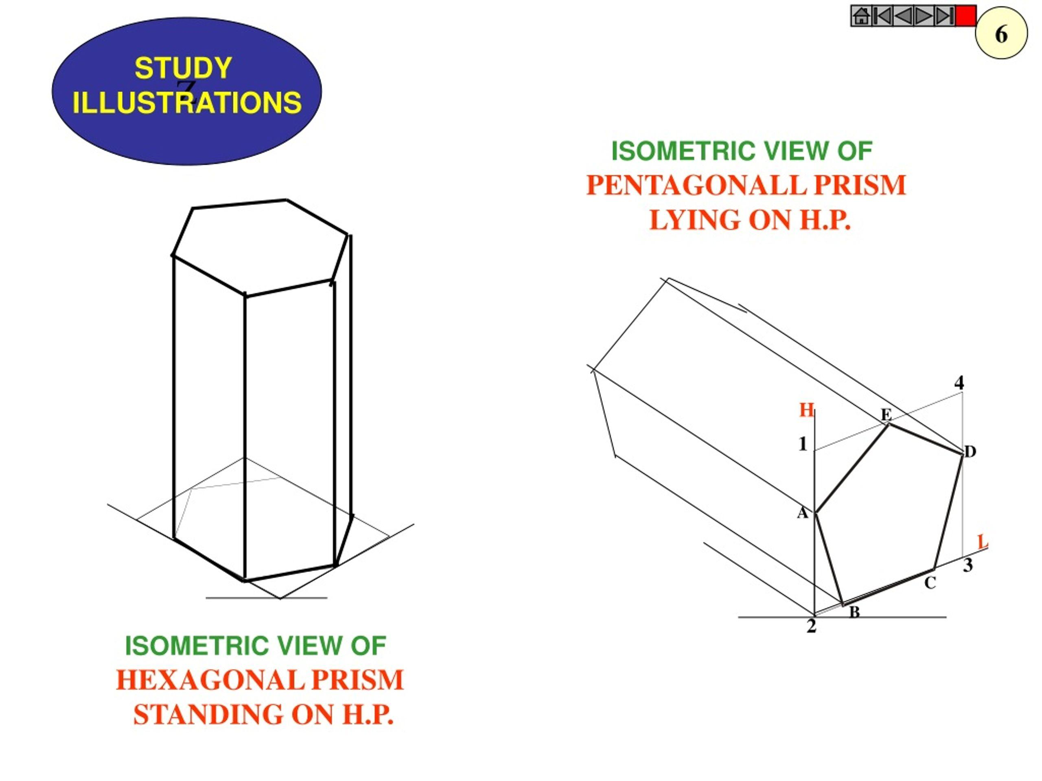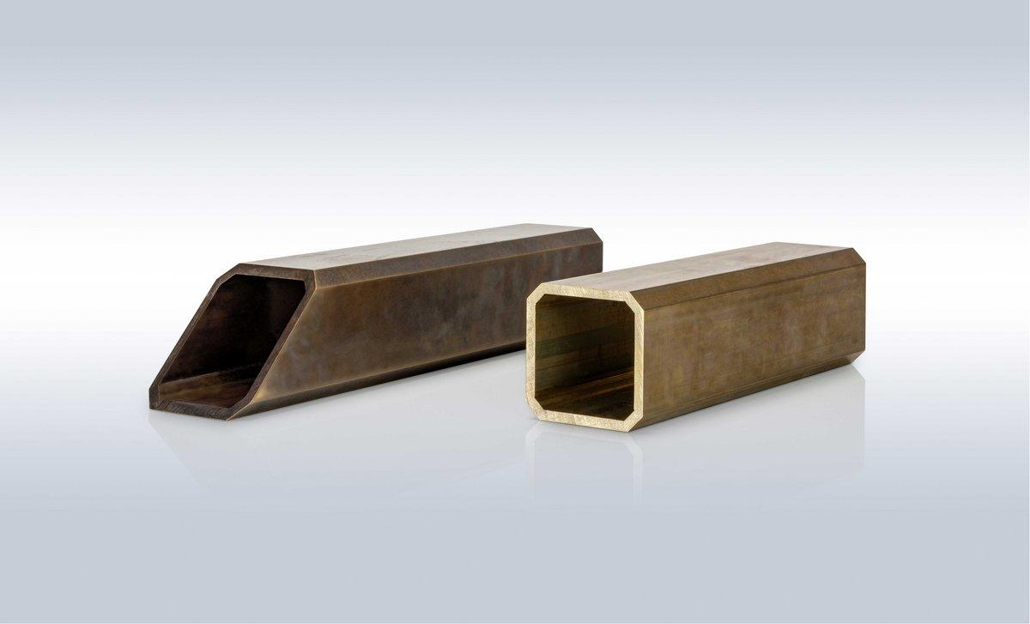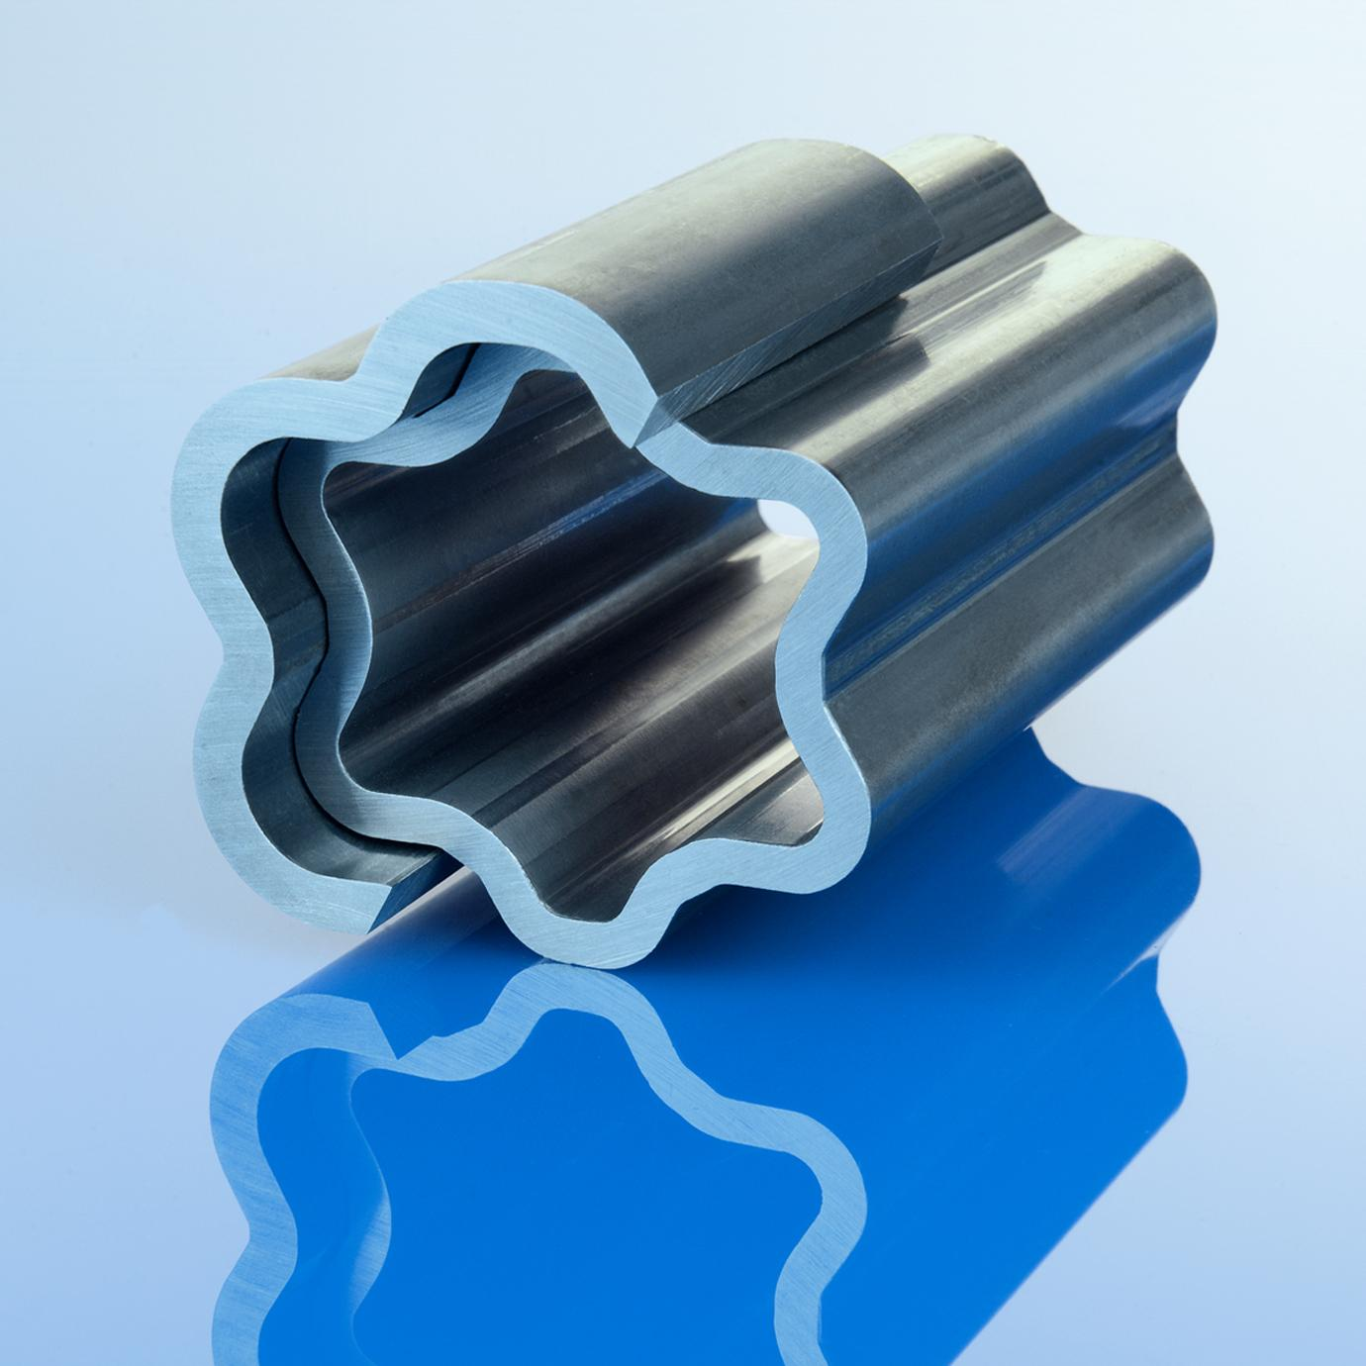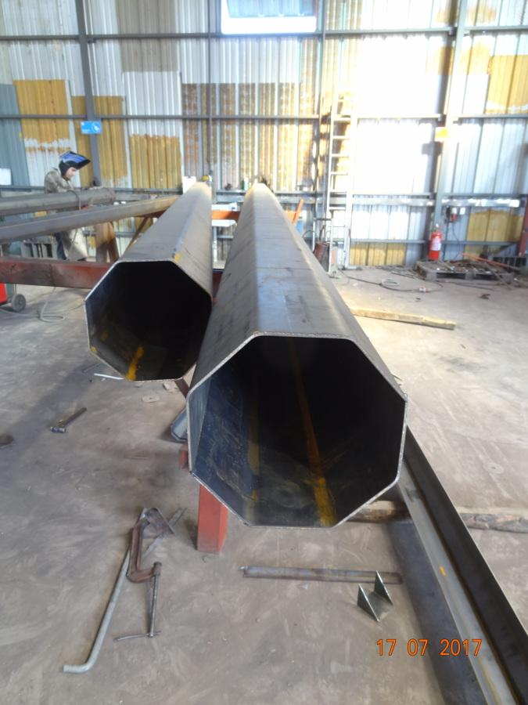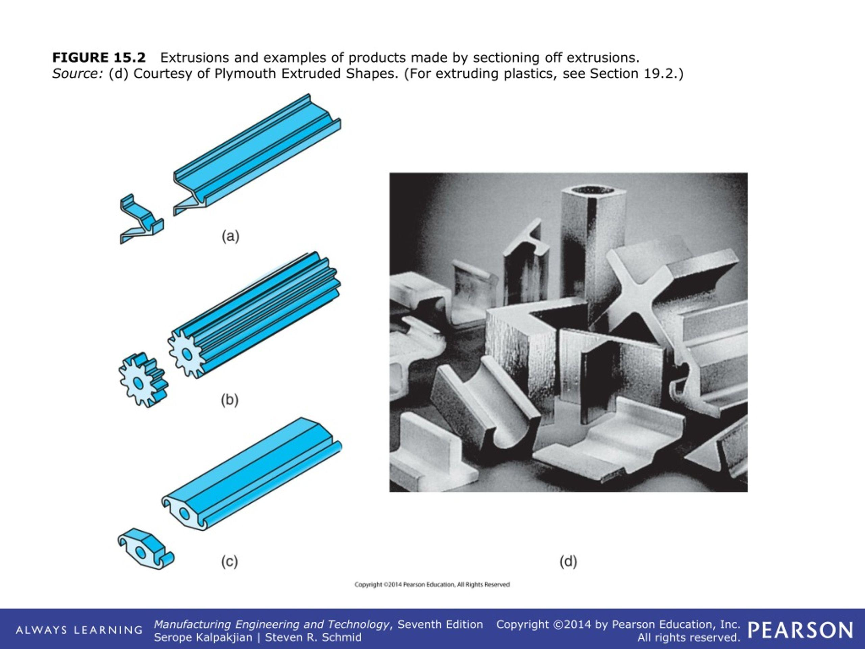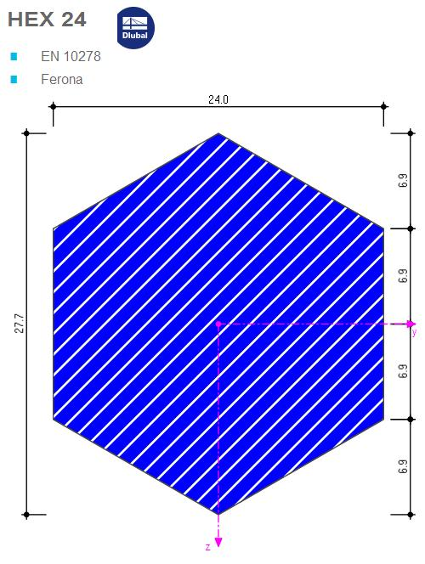
- Architecture: Polygonal columns, roofs, towers, and structural forms.
- Construction: Prismatic beams and polygonal structural components.
- Manufacturing: Extruded polygonal profiles and mechanical components.
- Packaging: Polygonal containers and prism-shaped packages.
- Engineering: Polygonal cross-sections used in structural and mechanical designs.
- Geometric Modeling: Creating complex solids from two-dimensional polygonal profiles.

Comparison with Other Plane-Region Generators
# Source: AI Source: Provided by: [Data Path: Persons Table -> ID Column: 1, Name_En Column: Motasem Essam] -> From: [ChatGPT] on [7/25/2026]
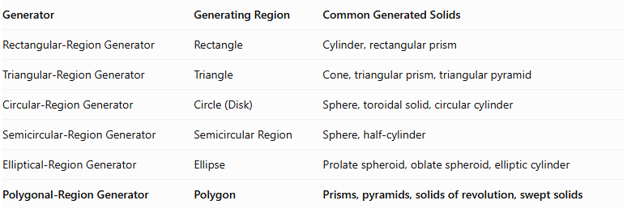
Generator | Generating Region | Common Generated Solids
Rectangular-Region Generator | Rectangle | Cylinder, rectangular prism
Triangular-Region Generator | Triangle | Cone, triangular prism, triangular pyramid
Circular-Region Generator | Circle (Disk) | Sphere, toroidal solid, circular cylinder
Semicircular-Region Generator | Semicircular Region | Sphere, half-cylinder
Elliptical-Region Generator | Ellipse | Prolate spheroid, oblate spheroid, elliptic cylinder
Polygonal-Region Generator | Polygon | Prisms, pyramids, solids of revolution, swept solids

Main Classification
# Source: AI Source: Provided by: [Data Path: Persons Table -> ID Column: 1, Name_En Column: Motasem Essam] -> From: [ChatGPT] on [7/25/2026]
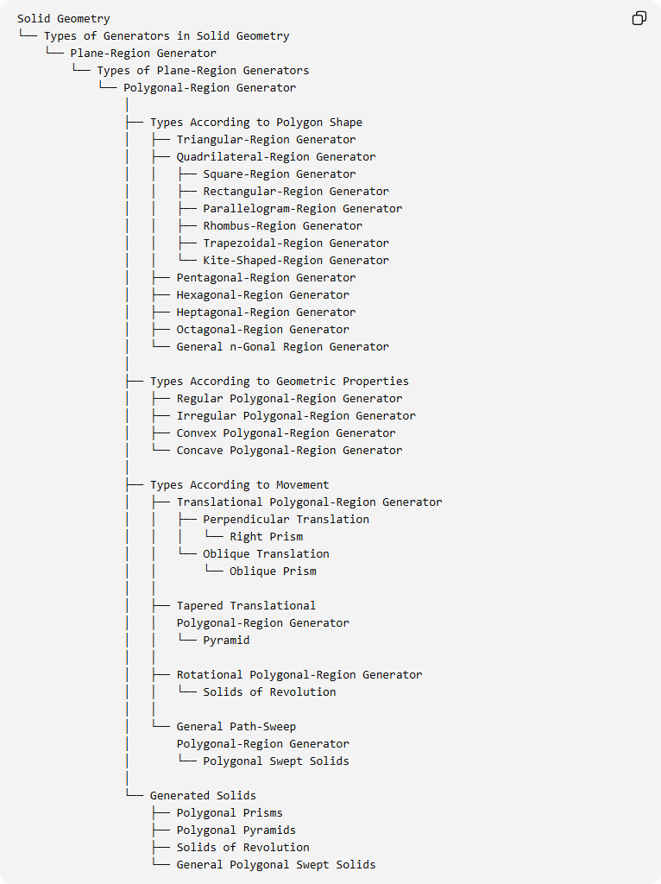
Solid Geometry
└── Types of Generators in Solid Geometry
└── Plane-Region Generator
└── Types of Plane-Region Generators
└── Polygonal-Region Generator
│
├── Types According to Polygon Shape
│ ├── Triangular-Region Generator
│ ├── Quadrilateral-Region Generator
│ │ ├── Square-Region Generator
│ │ ├── Rectangular-Region Generator
│ │ ├── Parallelogram-Region Generator
│ │ ├── Rhombus-Region Generator
│ │ ├── Trapezoidal-Region Generator
│ │ └── Kite-Shaped-Region Generator
│ ├── Pentagonal-Region Generator
│ ├── Hexagonal-Region Generator
│ ├── Heptagonal-Region Generator
│ ├── Octagonal-Region Generator
│ └── General n-Gonal Region Generator
│
├── Types According to Geometric Properties
│ ├── Regular Polygonal-Region Generator
│ ├── Irregular Polygonal-Region Generator
│ ├── Convex Polygonal-Region Generator
│ └── Concave Polygonal-Region Generator
│
├── Types According to Movement
│ ├── Translational Polygonal-Region Generator
│ │ ├── Perpendicular Translation
│ │ │ └── Right Prism
│ │ └── Oblique Translation
│ │ └── Oblique Prism
│ │
│ ├── Tapered Translational
│ │ Polygonal-Region Generator
│ │ └── Pyramid
│ │
│ ├── Rotational Polygonal-Region Generator
│ │ └── Solids of Revolution
│ │
│ └── General Path-Sweep
│ Polygonal-Region Generator
│ └── Polygonal Swept Solids
│
└── Generated Solids
├── Polygonal Prisms
├── Polygonal Pyramids
├── Solids of Revolution
└── General Polygonal Swept Solids

Key Points
# Source: AI Source: Provided by: [Data Path: Persons Table -> ID Column: 1, Name_En Column: Motasem Essam] -> From: [ChatGPT] on [7/25/2026]
- A polygonal-region generator uses a filled polygon as its generating figure.
- Polygonal regions can be triangular, quadrilateral, pentagonal, hexagonal, and other polygonal shapes.
- Polygonal regions can be classified as regular, irregular, convex, or concave.
- Translating a polygonal region generates a prism.
- Tapering a polygonal region toward an apex generates a pyramid.
- Rotating a polygonal region generates a solid of revolution.
- Sweeping a polygonal region along a general path generates a polygonal swept solid.
- The shape and dimensions of the generating polygon determine the cross-sectional geometry of the resulting solid.

Conclusion
# Source: AI Source: Provided by: [Data Path: Persons Table -> ID Column: 1, Name_En Column: Motasem Essam] -> From: [ChatGPT] on [7/25/2026]
The Polygonal-Region Generator is a general plane-region generator in solid geometry. It provides a foundation for generating polygonal prisms, pyramids, solids of revolution, and complex swept solids.
Its classification can be organized according to polygon shape, geometric properties, and movement method.

